Manual for Configuration and Usage of TDS Certificate Receivable Tracking

This utility lets you enter the details of TDS certificates received from different customers from time to time and adjust them against the TDS entries that you may have done in the past.

Summary of Modules Provided / Changed –
1. Making Receipt entry in Bank / Cash
2. Making TDS Adjustments through Journal Voucher
3. New TDS Certificate Receipt Entry Module
4. New TDS Certificate Pending Report
5. New TDS Certificate Pending Summary
6. New TDS Certificate Reminder Letter
7. New TDS Certificate Reminder Letter Email / Fax

1. BANK / CASH RECEIPT ENTRY

It is imperative that the receipt entries are done in the form shown below
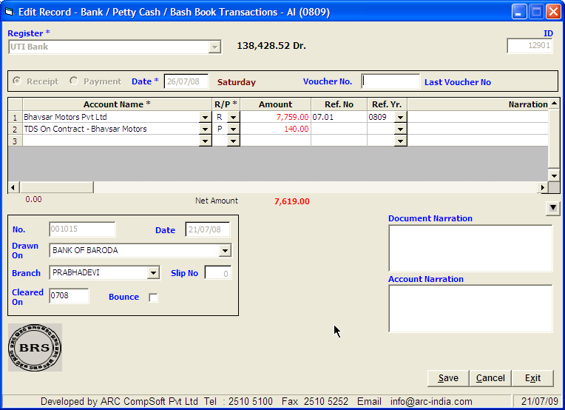

You need to maintain a separate TDS a/c for each of your customer accounts and debit this a/c while making a receipt entry.

2. TDS ADJUSTMENT ENTRY THROUGH JOURNAL VOUCHER
If any adjustments relating to TDS are required to be done thru JVs, then they should be done as shown.

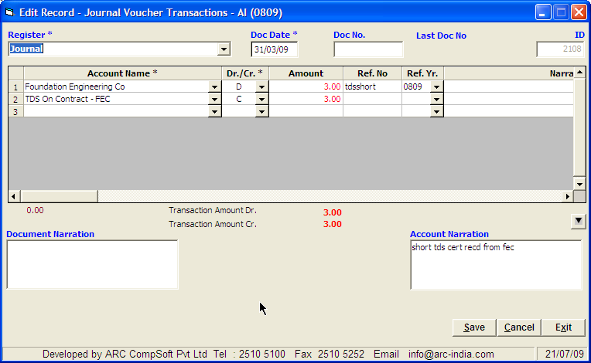

It is imperative that you include the customer’s account in the JV, otherwise such entries will not be reflected in this module.

3. TDS RECEIVABLE ENTRY MODULE

When ever you get a TDS certificate from the customer, details can be entered thru the TDS Cert Receipt entry module
Select Utilities -> TDS Receivable Options -> TDS Cert Receipt

Select the customer, enter the TDS certificate number, date and amount and click on [Get Data] button. All the receipts against which the TDS Cert. is yet to be received are displayed. Enter the amount mentioned in the certificate against one or more entries (just like the F7 interface you use to adjust the receipts against outstanding bills of customers). Once you are done, click on the [Save] button.

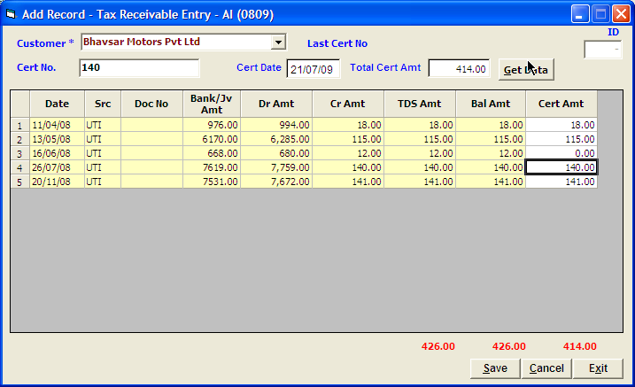

It is necessary that the total of all the amounts you adjust individually should be equal to the Total Cert. Amount you have entered on the top. If it does not match, then you cannot save the entry.

In the edit mode, you cannot include any more TDS amounts then what you had adjusted earlier, so in case if you wish to adjust the TDS certificate against different entries than what you had selected in while adding the entry, you have to delete the entry and enter the details again in the Add mode.

4. TDS CERTIFICATE PENDING REPORT

Select Utilities -> TDS Receivable Options -> TDS Cert Report & choose the required options and click on the [Preview] button

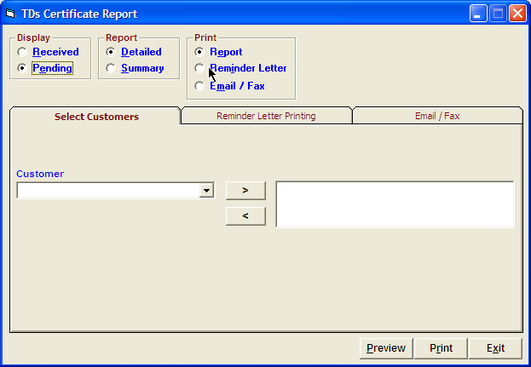

A report on TDS certificates yet to be received from various customers is displayed as under -

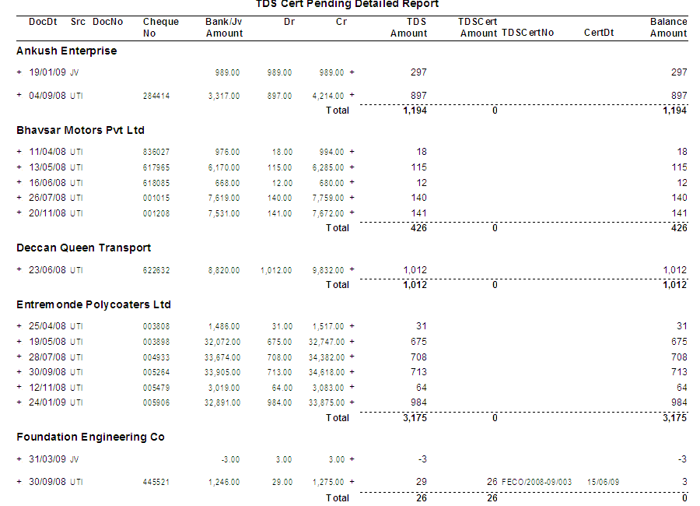

You can zoom in to any entry displayed in the above report by clicking on the + sign on the left hand side for the receipt entry and on the right hand side for the TDS Certificate Receipt entry.

5. TDS CERTIFICATE PENDING SUMMARY

You can also opt for a summary of the above report by choosing the Summary option

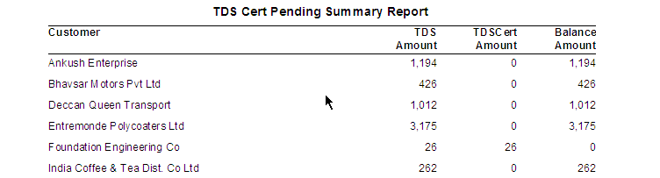

6. TDS CERTIFICATE REMINDER LETTER

You also have an option to print Reminder letter for the TDS certificates

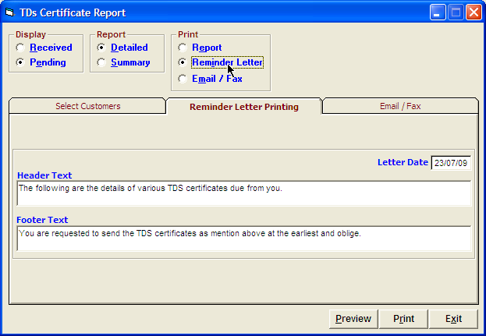

Select the appropriate option, edit the header and footer text if required and click on [Preview] button.

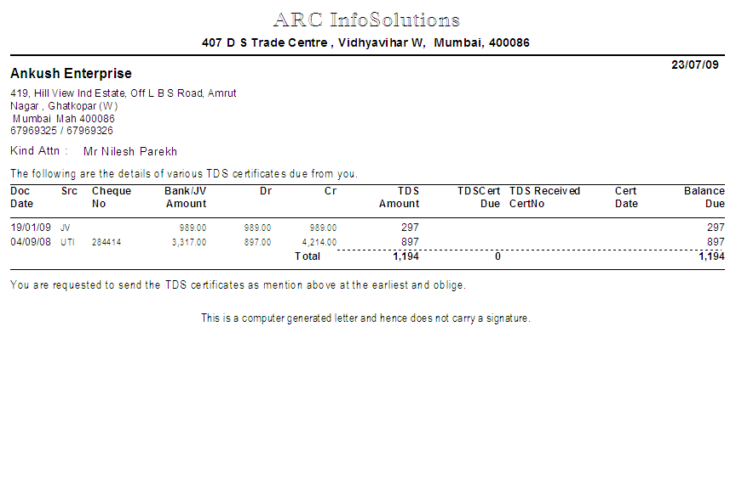

If required, you can send emails of the reminder letter to multiple customers at one shot.

7. TDS CERTIFICATE REMINDER LETTER EMAIL / FAX OPTION

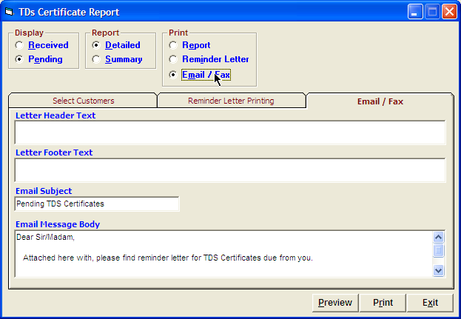

Select the appropriate option, edit the header and footer text if required and click on [Preview] button.
A list of customers from whom the TDS certificates are yet to be received is displayed along with their email IDs and Fax numbers (if available in the accounts master)

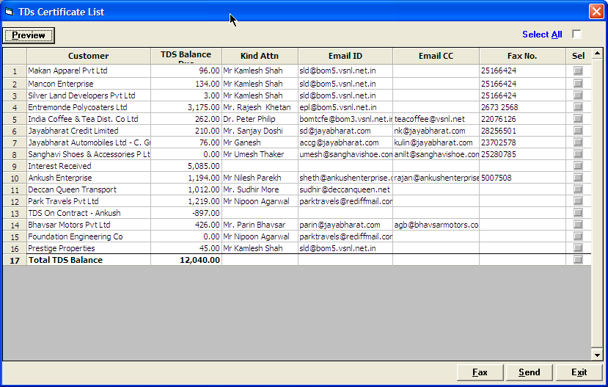

Select the customers and then click on the [Fax] button to send a fax or the [Send] button to send an email.

If the email id or the fax number is not entered in the accounts master, you can enter the details here and update the customer’s account by right clicking on the customer and selecting the ‘Update’ option.

-------- о --------

