Detailed explanation about configuring the automatic TDS module in ASCFAWin .

Step 1 : Enable Automatic TDS Module
Step 2 : Create a special Accounts group for various TDS accounts and add accounts under this group
Step 3 : Add new Journal Register for holding TDS Entries
Step 4 : Addition of Education Cess / Surcharge Accounts (if required to be maintained separately)
Step 5 : Defining the TDS Chart
Step 6 : Addition of Expense Entries through Journal or Expense Register.
Step 7 : Executing TDS Entries
Step 8 : Printing of TDS Challans
Step 9 : Updation of Challan details
Step 9a : Updation of Quarterly TDS Return Acknowledgement number
Step 10: TDS Certificates printing
Step 11: Quarterly TDS Report.

Step 1: Enable Automatic TDS Module

For the company in which you plan to configure the automatic TDS module ensure that in the Company Master “Enabled Automatic TDS Module” is checked as shown below

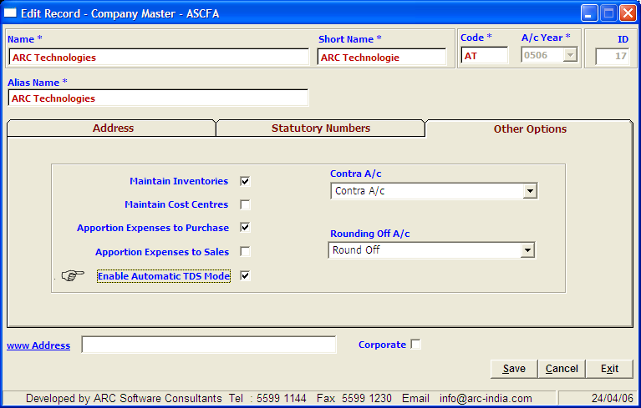

In the menu click “Masters -> Companies -> Record -> Modify”

Step 2: Create a special Accounts group for various TDS and E.Cess accounts and add the requisite accounts under this group

You need to create a special accounts group for the various TDS accounts that you will credit while deducting TDS, and they are to be defined in a separate accounts group under Balance Sheet category “TAX DEDUCTED AT SOURCE” as shown below

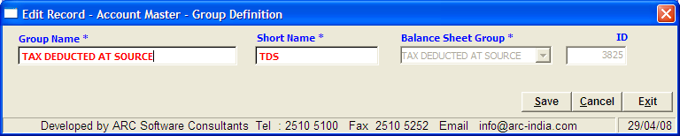

In the menu click “Masters -> Accounts -> Record -> Add group”

You also need to add various TDS accounts for each type of Tax deducted while making different types of payments pertaining to Salary, Prof. Charges, Interest, Sub contracting charges, etc under the newly created TDS account group as shown below.
In the menu click “Masters -> Accounts -> Record -> Add Account”
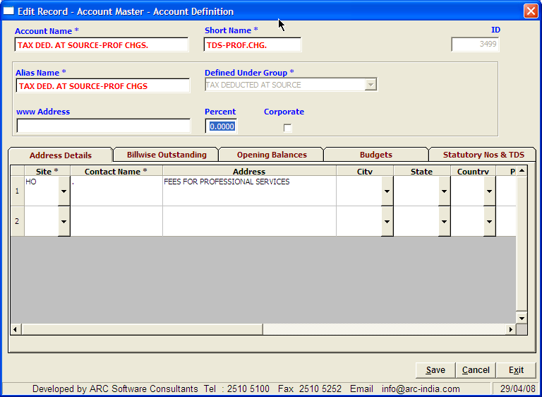

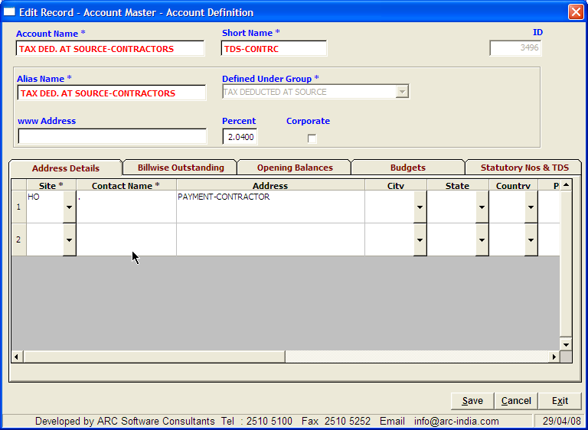 
Step 3: Add new Journal Register for holding TDS Entries

To use automatic TDS module you also have to define a Journal Register specifically for holding TDS entries as shown below

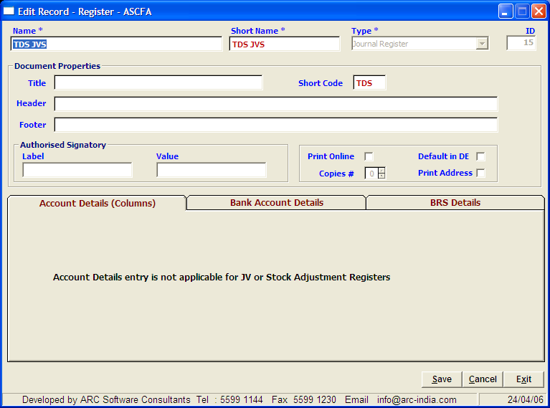

In the menu click “Masters -> Registers -> Record -> Add Record”

After saving the above entry, in the browse grid of Register master, right click on TDS JV register that you have defined and click “TDS JV …” as shown below.

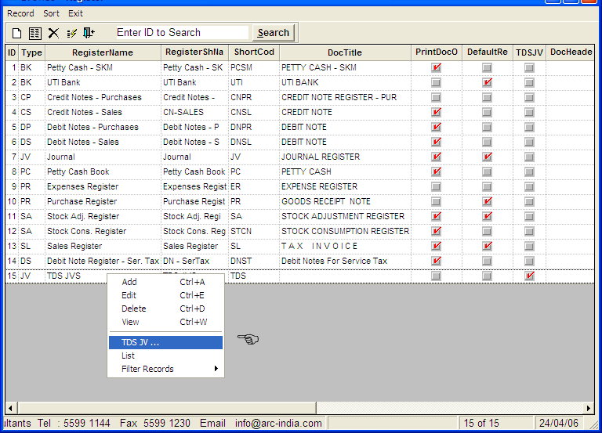

By doing this the software will know the Journal Register under which the TDS entries are to be added.

Please note that whatever entries get added under this register automatically through TDS Module cannot be edited through the Journal Entry Module. You can only delete the entries if they are not required.



Step 4: Addition of Education Cess / Surcharge Accounts and sub accounts (if required to be maintained separately)

If you do not wish to keep a separate account for Education Cess and Surcharge then jump to step no. 5 otherwise you also have to create Education Cess and Surcharge accounts under the same TDS Accounts group as shown below.

Preferably create an account for EC 2%
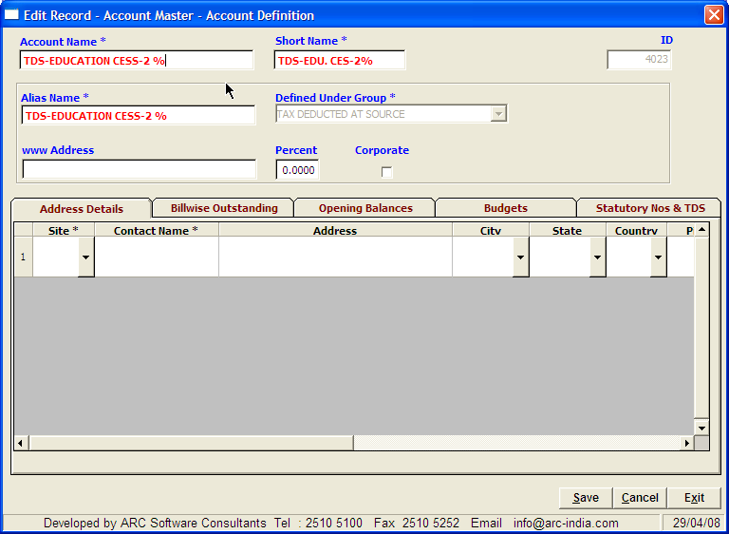

and sub accounts under it for various types of charges

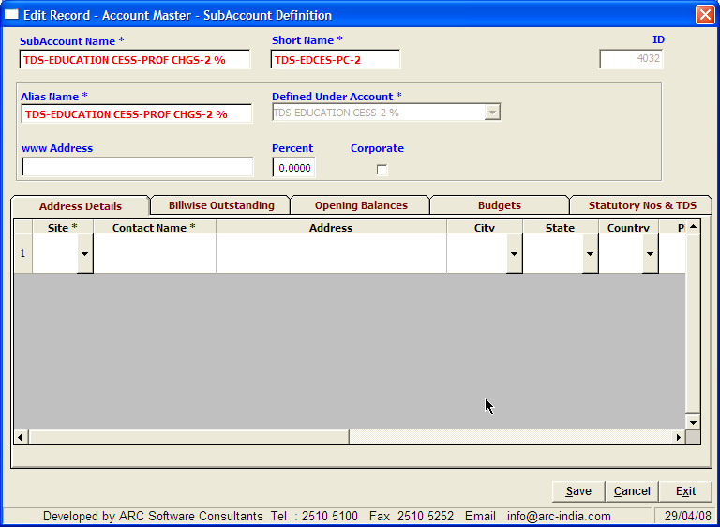

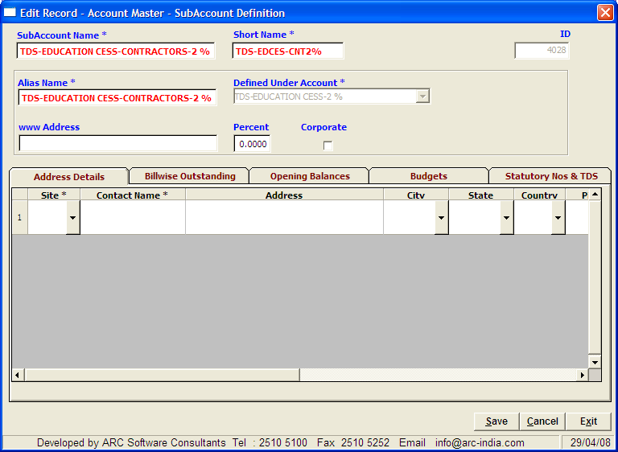

Same thing applies for SHEC1%

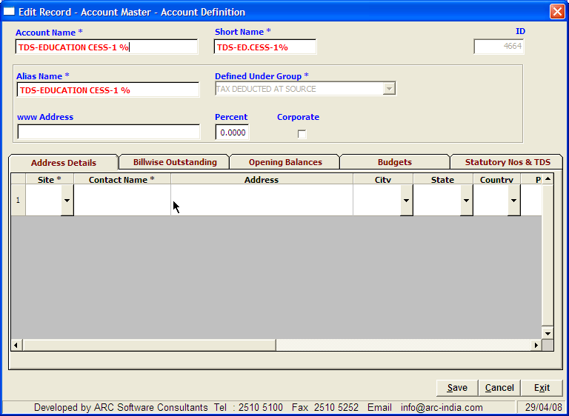

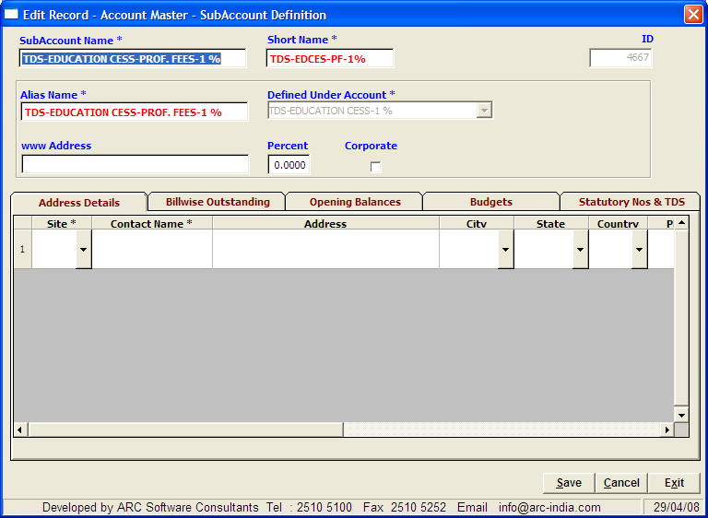

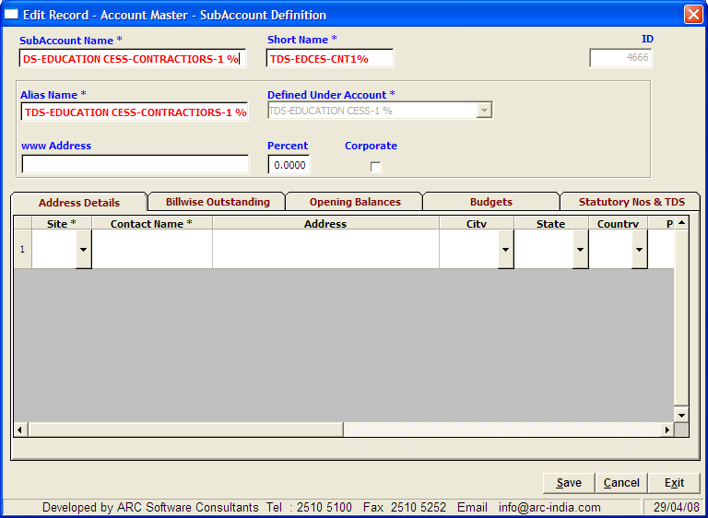

Similarly add a surcharge account if required

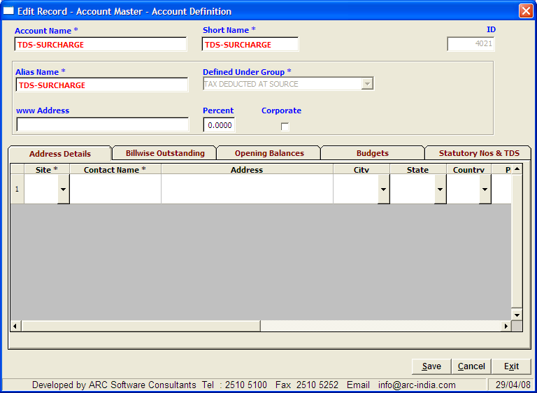

And sub account for the different charges

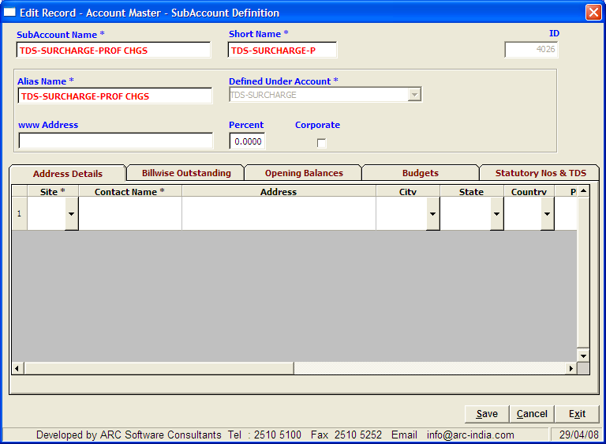

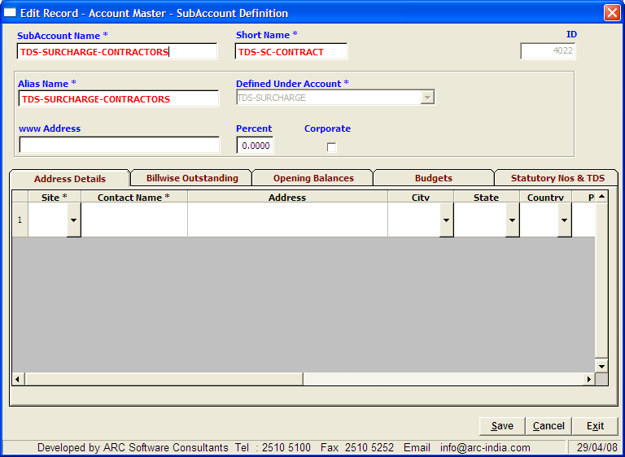
  

Step 5: Defining the TDS Chart

Once having done this you are ready to define the TDS chart based upon which the automatic TDS module will work.
Click on Utilities -> TDS Options -> TDS Definition and enter relevant information applicable to your requirements.

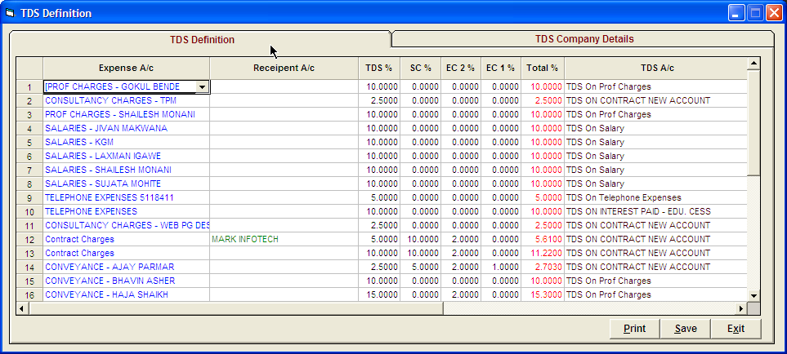

For generating form 26Q, there are additional requirements to be fed in about the company deducting tax.

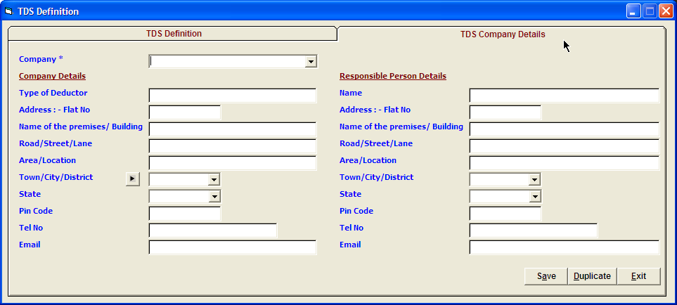

A sample TDS definition chart is shown below for reference.
TDS Account Definition

Expense A/c | Receipent A/c | TDS % | SC % | EC 2 % | EC 1 % | Total % | TDS A/c | Surcharge A/c | Edu Cess 2 A/c | Edu Cess 1 A/c | Threshold Amt | TDS Code
AUDIT FEES |  | 10 | 0 | 2 | 1 | 10.3 | TAX DED. AT SOURCE-PROF CHGS. |  | TDS-EDUCATION CESS-PROF CHGS-2 % | TDS-EDUCATION CESS-PROF. FEES-1 % | 20,000 | 94J
COMMISSION |  | 10 | 0 | 2 | 1 | 10.3 | TAX DED. AT SOURCE-OTHERS |  | TDS-EDUCATION CESS-COMM & BRK-2 % | TDS-EDUCATION CESS-COMM & BRK-1 % | 2,500 | 94H
LABOUR CHARGES-METAL FABRICATION |  | 2 | 0 | 2 | 1 | 2.06 | TAX DED. AT SOURCE-CONTRACTORS-NON CORP. |  | TDS-EDUCATION CESS-CONTRACTORS-2 % | TDS-EDUCATION CESS-CONTRACTIORS-1 % | 20,000 | 94C
LABOUR CHARGES-OTHERS |  | 2 | 0 | 2 | 1 | 2.06 | TAX DED. AT SOURCE-CONTRACTORS-NON CORP. |  | TDS-EDUCATION CESS-CONTRACTORS-2 % | TDS-EDUCATION CESS-CONTRACTIORS-1 % | 20,000 | 94C
LABOUR CHARGES-PAINTING CHARGES | PERFECT COATS | 2 | 0 | 2 | 1 | 2.06 | TAX DED. AT SOURCE-CONTRACTORS-NON CORP. |  | TDS-EDUCATION CESS-CONTRACTORS-2 % | TDS-EDUCATION CESS-CONTRACTIORS-1 % | 20,000 | 94C
LABOUR CHARGES-PLASTIC FABRICATION | PLASTICATORS | 2 | 0 | 2 | 1 | 2.06 | TAX DED. AT SOURCE-CONTRACTORS-NON CORP. |  | TDS-EDUCATION CESS-CONTRACTORS-2 % | TDS-EDUCATION CESS-CONTRACTIORS-1 % | 20,000 | 94C
LABOUR CHARGES-PLATING CHARGES |  | 2 | 0 | 2 | 1 | 2.06 | TAX DED. AT SOURCE-CONTRACTORS-NON CORP. |  | TDS-EDUCATION CESS-CONTRACTORS-2 % | TDS-EDUCATION CESS-CONTRACTIORS-1 % | 20,000 | 94C
POSTAGE & COURIER | MAIL MAN EXPRESS PVT. LTD. | 2 | 10 | 2 | 1 | 2.266 | TAX DED. AT SOURCE-CONTRACTORS-CORP. | TDS-SURCHARGE-CONTRACTORS | TDS-EDUCATION CESS-CONTRACTORS-2 % | TDS-EDUCATION CESS-CONTRACTIORS-1 % | 0 | 94C
POSTAGE & COURIER |  | 2 | 0 | 2 | 1 | 2.06 | TAX DED. AT SOURCE-CONTRACTORS-NON CORP. |  | TDS-EDUCATION CESS-CONTRACTORS-2 % | TDS-EDUCATION CESS-CONTRACTIORS-1 % | 20,000 | 94C
PROFESSIONAL CHARGES | GRAND STAND COMMUNICATION | 10 | 0 | 2 | 1 | 10.3 | TAX DED. AT SOURCE-PROF CHGS. |  | TDS-EDUCATION CESS-PROF CHGS-2 % | TDS-EDUCATION CESS-PROF. FEES-1 % | 10,000 | 94J
PURCHASES-IMPORT-C&F AGENCY CHARGES |  | 10 | 0 | 2 | 1 | 10.3 | TAX DED. AT SOURCE-OTHERS |  | TDS-EDUCATION CESS-COMM & BRK-2 % | TDS-EDUCATION CESS-COMM & BRK-1 % | 2,500 | 94H
REPAIRS & MAINTENANCE |  | 2 | 0 | 2 | 1 | 2.06 | TAX DED. AT SOURCE-CONTRACTORS-NON CORP. |  | TDS-EDUCATION CESS-CONTRACTORS-2 % | TDS-EDUCATION CESS-CONTRACTIORS-1 % | 20,000 | 94C
REPAIRS & MAINTENANCE-FACTORY BLDG. |  | 2 | 0 | 2 | 1 | 2.06 | TAX DED. AT SOURCE-CONTRACTORS-NON CORP. |  | TDS-EDUCATION CESS-CONTRACTORS-2 % | TDS-EDUCATION CESS-CONTRACTIORS-1 % | 20,000 | 94C
REPAIRS & MAINTENANCE-PLANT & MACH. |  | 2 | 0 | 2 | 1 | 2.06 | TAX DED. AT SOURCE-CONTRACTORS-NON CORP. |  | TDS-EDUCATION CESS-CONTRACTORS-2 % | TDS-EDUCATION CESS-CONTRACTIORS-1 % | 20,000 | 94C
SECURITY CHARGES |  | 2 | 10 | 2 | 1 | 2.266 | TAX DED. AT SOURCE-CONTRACTORS | TDS-SURCHARGE-CONTRACTORS | TDS-EDUCATION CESS-CONTRACTORS-2 % | TDS-EDUCATION CESS-CONTRACTIORS-1 % | 20,000 | 94C
REPAIRS & MAINTENANCE-P&M-LAB.CHGS. |  | 2 | 0 | 2 | 1 | 2.06 | TAX DED. AT SOURCE-CONTRACTORS-NON CORP. |  | TDS-EDUCATION CESS-CONTRACTORS-2 % | TDS-EDUCATION CESS-CONTRACTIORS-1 % | 20,000 | 94C
REPAIRS & MAINTENANCE-F&F-LABOUR CHGS. |  | 2 | 0 | 2 | 1 | 2.06 | TAX DED. AT SOURCE-CONTRACTORS-NON CORP. |  | TDS-EDUCATION CESS-CONTRACTORS-2 % | TDS-EDUCATION CESS-CONTRACTIORS-1 % | 20,000 | 94C
REPAIRS & MAINTENANCE-PREMISES-LAB.CHGS. | BIBHUTI YADAV | 2 | 0 | 2 | 1 | 2.06 | TAX DED. AT SOURCE-CONTRACTORS-NON CORP. |  | TDS-EDUCATION CESS-CONTRACTORS-2 % | TDS-EDUCATION CESS-CONTRACTIORS-1 % | 20,000 | 94C
FREIGHT OUTWARD | SHASHIKANT A. RAHATE | 2 | 0 | 2 | 1 | 2.06 | TAX DED. AT SOURCE-CONTRACTORS-NON CORP. |  | TDS-EDUCATION CESS-CONTRACTORS-2 % | TDS-EDUCATION CESS-CONTRACTIORS-1 % | 0 | 94C
PROFESSIONAL CHARGES | SUMEET FACILITIES PVT LTD | 10 | 10 | 2 | 1 | 11.33 | TAX DED. AT SOURCE-PROF CHGS. | TDS-SURCHARGE-PROF CHGS | TDS-EDUCATION CESS-PROF CHGS-2 % | TDS-EDUCATION CESS-PROF. FEES-1 % | 10,000 | 94J
PROFESSIONAL CHARGES | D. D. GHANGURDE | 10 | 0 | 2 | 1 | 10.3 | TAX DED. AT SOURCE-PROF CHGS. |  | TDS-EDUCATION CESS-PROF CHGS-2 % | TDS-EDUCATION CESS-PROF. FEES-1 % | 10,000 | 94J
PROFESSIONAL CHARGES | ARC SOFTWARE CONSULTANTS (S. Crs.-Exps) | 10 | 0 | 2 | 1 | 10.3 | TAX DED. AT SOURCE-PROF CHGS. |  | TDS-EDUCATION CESS-PROF CHGS-2 % | TDS-EDUCATION CESS-PROF. FEES-1 % | 10,000 | 94J
MOTOR CAR HIRE PURCHASE CHARGES |  | 20 | 10 | 2 | 1 | 22.66 | TAX DED. AT SOURCE-RENT | TDS-SURCHARGE-RENT | TDS-EDUCATION CESS -RENT-2 % | TDS-EDUCATION CESS-1 % | 0 | 94I
PROFESSIONAL CHARGES | ARC SOFTWARE TECNOLOGIES | 10 | 0 | 2 | 1 | 10.3 | TAX DED. AT SOURCE-PROF CHGS. |  | TDS-EDUCATION CESS-PROF CHGS-2 % | TDS-EDUCATION CESS-PROF CHGS-2 % | 10,000 | 94J
PROFESSIONAL CHARGES | SHAH, SHAH & SHAH | 10 | 0 | 2 | 1 | 10.3 | TAX DED. AT SOURCE-PROF CHGS. |  | TDS-EDUCATION CESS-PROF CHGS-2 % | TDS-EDUCATION CESS-PROF. FEES-1 % | 10,000 | 94J
COMPENSATION |  | 20 | 10 | 2 | 1 | 22.66 | TAX DED. AT SOURCE-RENT | TDS-SURCHARGE-RENT | TDS-EDUCATION CESS -RENT-2 % | TDS-EDUCATION CESS-RENT-1 % | 120,000 | 94I
COMPENSATION | SHANTILAL & CO. PVT. LTD.-S.CRS.-EXPS. | 20 | 10 | 2 | 1 | 22.66 | TAX DED. AT SOURCE-RENT | TDS-SURCHARGE-RENT | TDS-EDUCATION CESS -RENT-2 % | TDS-EDUCATION CESS-RENT-1 % | 120,000 | 94I
DESIGN & DEVELOPMENT EXPENSES |  | 2 | 0 | 2 | 1 | 2.06 | TAX DED. AT SOURCE-CONTRACTORS-NON CORP. |  | TDS-EDUCATION CESS-CONTRACTORS-2 % | TDS-EDUCATION CESS-CONTRACTIORS-1 % | 20,000 | 94C
DESIGN & DEVELOPMENT EXPENSES | DHL WORLDWIDE EXPRESS (I) PVT.LTD | 2 | 10 | 2 | 1 | 2.266 | TAX DED. AT SOURCE-CONTRACTORS-CORP. | TDS-SURCHARGE-CONTRACTORS | TDS-EDUCATION CESS-CONTRACTORS-2 % | TDS-EDUCATION CESS-CONTRACTIORS-1 % | 0 | 94C
FREIGHT INWARD |  | 2 | 0 | 2 | 1 | 2.06 | TAX DED. AT SOURCE-CONTRACTORS-NON CORP. |  | TDS-EDUCATION CESS-CONTRACTORS-2 % | TDS-EDUCATION CESS-CONTRACTIORS-1 % | 20,000 | 94C
FREIGHT OUTWARD | R.A.RAHATE | 2 | 0 | 2 | 1 | 2.06 | TAX DED. AT SOURCE-CONTRACTORS-NON CORP. |  | TDS-EDUCATION CESS-CONTRACTORS-2 % | TDS-EDUCATION CESS-CONTRACTIORS-1 % | 0 | 94C
FREIGHT OUTWARD -THORN |  | 2 | 0 | 2 | 1 | 2.06 | TAX DED. AT SOURCE-CONTRACTORS-NON CORP. |  | TDS-EDUCATION CESS-CONTRACTORS-2 % | TDS-EDUCATION CESS-CONTRACTIORS-1 % | 20,000 | 94C
FREIGHT OUTWARD-EXPORTS |  | 2 | 0 | 2 | 1 | 2.06 | TAX DED. AT SOURCE-CONTRACTORS-NON CORP. |  | TDS-EDUCATION CESS-CONTRACTORS-2 % | TDS-EDUCATION CESS-CONTRACTIORS-1 % | 20,000 | 94C
FREIGHT OUTWARD-EXPORTS-AGENCY CHGS |  | 10 | 0 | 2 | 1 | 10.3 | TAX DED. AT SOURCE-OTHERS |  | TDS-EDUCATION CESS-COMM & BRK-2 % | TDS-EDUCATION CESS-COMM & BRK-1 % | 0 | 94H
INTEREST PAID ON LOANS-COMPANIES |  | 20 | 10 | 2 | 1 | 22.66 | TAX DED. AT SOURCE-INTEREST | TDS-SURCHARGE-INTEREST | TDS- EDUCATION CESS- INTEREST-2 % | TDS-EDUCATION CESS-INTEREST-1 % | 0 | 94A
INTEREST PAID ON LOANS-OTHERS |  | 10 | 0 | 2 | 1 | 10.3 | TAX DED. AT SOURCE-INTEREST |  | TDS- EDUCATION CESS- INTEREST-2 % | TDS-EDUCATION CESS-INTEREST-1 % | 0 | 94A
LABOUR CHARGES |  | 2 | 0 | 2 | 1 | 2.06 | TAX DED. AT SOURCE-CONTRACTORS-NON CORP. |  | TDS-EDUCATION CESS-CONTRACTORS-2 % | TDS-EDUCATION CESS-CONTRACTIORS-1 % | 20,000 | 94C
LABOUR CHARGES-BENDING CHARGES |  | 2 | 0 | 2 | 1 | 2.06 | TAX DED. AT SOURCE-CONTRACTORS-NON CORP. |  | TDS-EDUCATION CESS-CONTRACTORS-2 % | TDS-EDUCATION CESS-CONTRACTIORS-1 % | 20,000 | 94C
LABOUR CHARGES-BLASTING CHARGES |  | 2 | 0 | 2 | 1 | 2.06 | TAX DED. AT SOURCE-CONTRACTORS-NON CORP. |  | TDS-EDUCATION CESS-CONTRACTORS-2 % | TDS-EDUCATION CESS-CONTRACTIORS-1 % | 20,000 | 94C
LABOUR CHARGES-CAPITAL-ITEMS |  | 2 | 0 | 2 | 1 | 2.06 | TAX DED. AT SOURCE-CONTRACTORS-NON CORP. |  | TDS-EDUCATION CESS-CONTRACTORS-2 % | TDS-EDUCATION CESS-CONTRACTIORS-1 % | 20,000 | 94C

Please note the following:-

- You cannot repeat an Expense account in the above table.
- You cannot repeat a combination of the same Expense and Recipient account.
- You can repeat the expense account provided the recipients are different.
- Defining TDS percentage is necessary but you can skip the entry of Surcharge and Education Cess percentage if you wish.
- Defining TDS account to be credited is also necessary.
- Defining Surcharge account to be credited is compulsory, if Surcharge percentage is entered.
- Defining Education Cess account to be credited is compulsory, if Education Cess percentage is entered.
- Its very important to define the appropriate TDS code.
- If the TDS percentage is 10 and Education Cess is 2 %, you have an option of defining the TDS percentage as 10.2 and leave the Education Cess percentage as 0 or alternatively you can define TDS percentage as 10 and Education Cess as 2 % separately. In later case you will be able to maintain a separate Education Cess account for easy calculation of set off.
- The above logic holds true for Surcharge too.

The above table will be referred to while determining the entries which are eligible for TDS, if the expense plus recipient combination is present in an entry and also in TDS chart then the appropriate TDS percentage will be picked up from the expense plus recipient combination. Hence, if only the expense account is found in the above TDS chart then the TDS percentage defined against the expense will be made applicable. 

Step 6: Addition of Expense Entries through Journal or Expense Register

This is all you need to do as far as configuration of the TDS module is concerned. Once the configuration chart is ready, you are now ready to deduct TDS automatically from the entries that you may have done through Expense Register or Journal Vouchers, which may be on the following lines.

Example of Professional Charges Payable – booked thru a Journal entry.

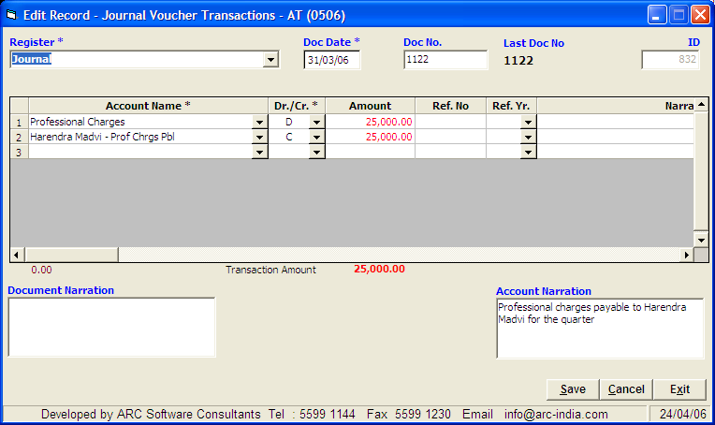

Example of Sub Contracting bill booked thru Expense Register.

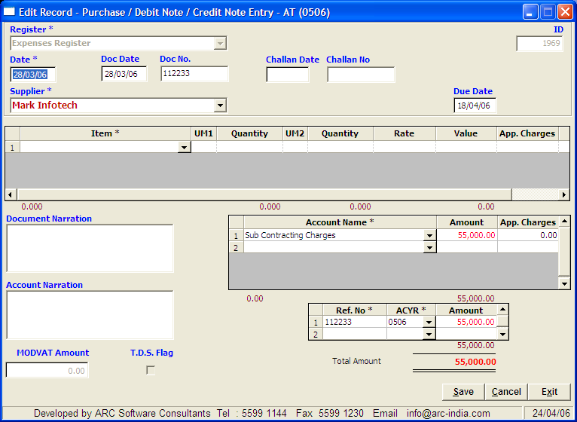

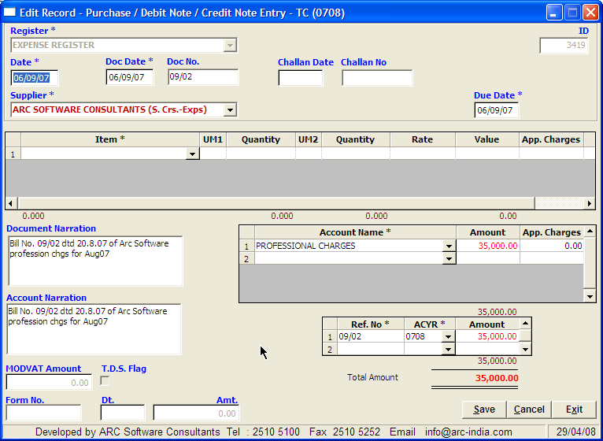

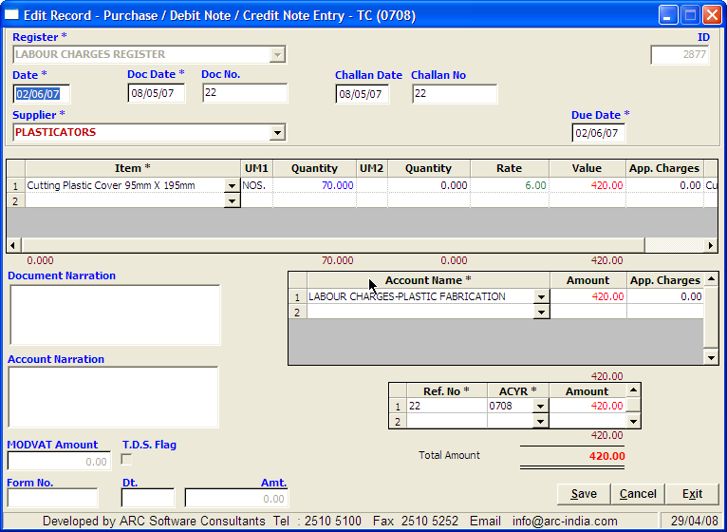

It is highly recommended that you make all your entries through the Expense Register as it is a highly structured entry module and picking up the information accurately is possible. Since Journal Entries are highly unstructured it becomes difficult for TDS module to pick up the information accurately and hence should be avoided as far as possible.
 

Step 7: Executing TDS Entries

Select “Utilities -> TDS option -> Generate TDS JVs” from the menu. Enter the dates within which the records are to be considered for inclusion in the TDS JVs and click on the button. On doing so the all the entries which are eligible for deduction of TDS will be displayed (as per the TDS chart defined earlier in Step 5).

Make sure all the options in the form are selected properly. Select the individual entry by clicking under the select column and then select the appropriate options. Once you are sure of all the options selected click on  button and on doing so you will be asked to confirm whether you want to add the TDS entry. Select the appropriate answer.

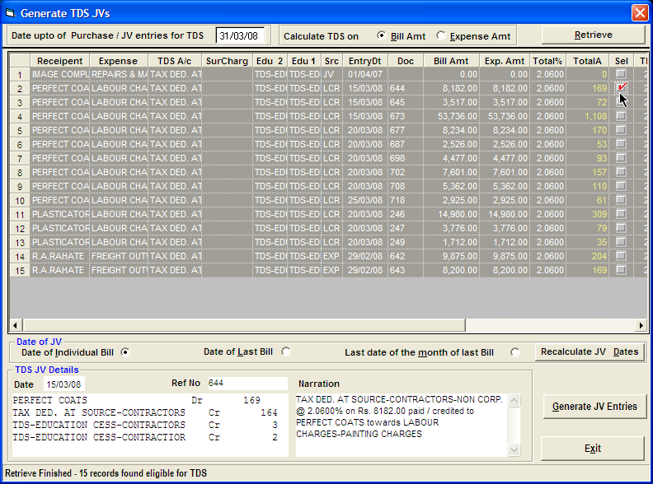

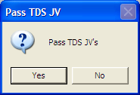

Once you click on the Yes button, the requisite journal entries are automatically added under the TDS register which you have defined earlier in step 3. For easy understanding of the TDS JV, the entire JV is displayed at the bottom left corner of the form along with the narration. If required you can change the narration at this point before clicking on Generate JV Entries Button.

Once you generate the JV entries, the corresponding entry will disappear from the above form.

If for any reason after adding the TDS JV, you feel that the entry is wrong, just go to the JV entry module and delete the specific entry. Having done that the Purchase / Journal Entry will appear again in the Generate TDS module.

After having passed a TDS JV against the Purchase / Journal Entry you cannot modify the same. If for any reason a change is required, you will have to delete the TDS JV as explained above make changes in corresponding Expense / Journal Entry and re run the Generate TDS JV module again to deduct TDS from that particular entry.

Since these entries are depended on each other absolute care should be taken that whatever entries you are adding automatically are proper and accurate.

Step 8: Printing of TDS Challans

Once you have executed TDS entries on all the applicable expenses / payments and wish to print the TDS challan, select the challan print option and update option to display the interface as shown below

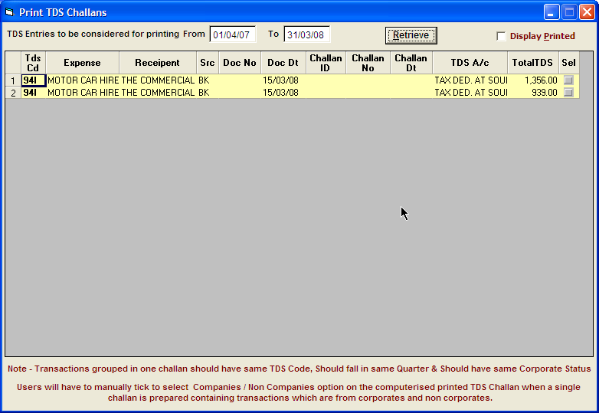
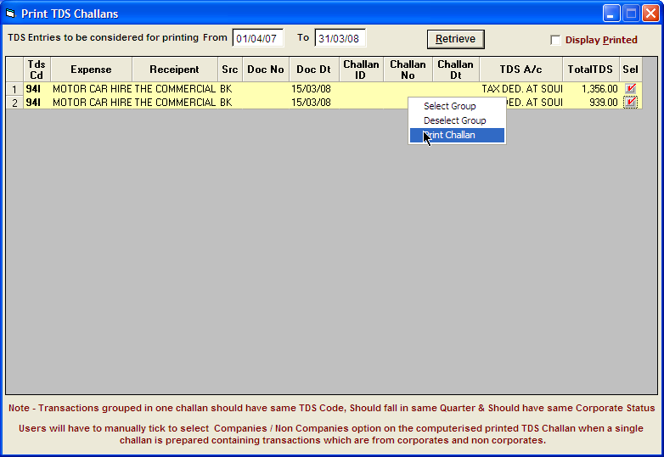

Wherein all the TDS entries will be shown grouped by the TDS code.

Select the required entries and right click on any one selected entry and select “Print Challan” as shown below

on doing so you need to enter the amount of interest, penalty or other charges as well as cheque details. Click on the  button to generate the challan.

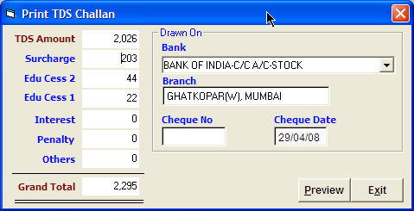

On doing so a challan will be display on the screen with all the requisite information.

Please note that while selecting the records, you cannot mix corporate and non corporate recipients. Also you cannot select entries from different TDS codes.

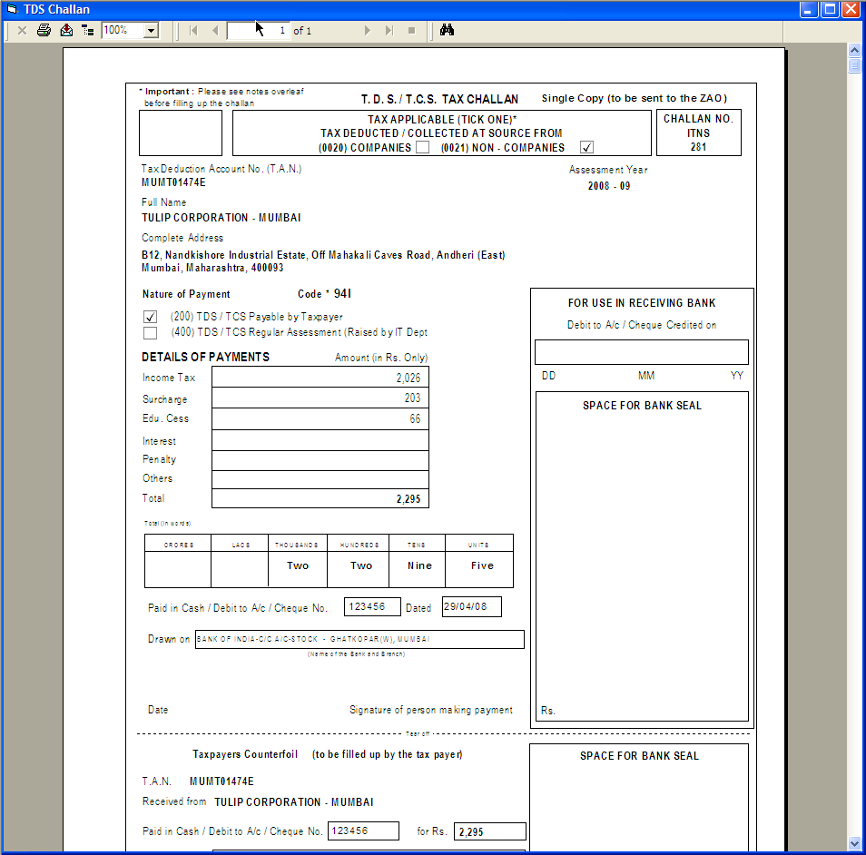

This way you can print challans for different types of the TDS deducted under different TDS codes for payment at the end of the month or beginning of the month.

If for any reason you wish to re-print challans click on the check box as shown below

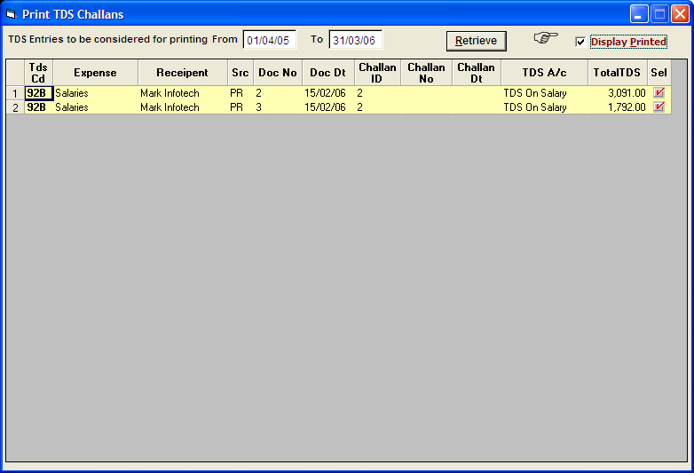

and right click on the required challan and select “Reprint Challan” option

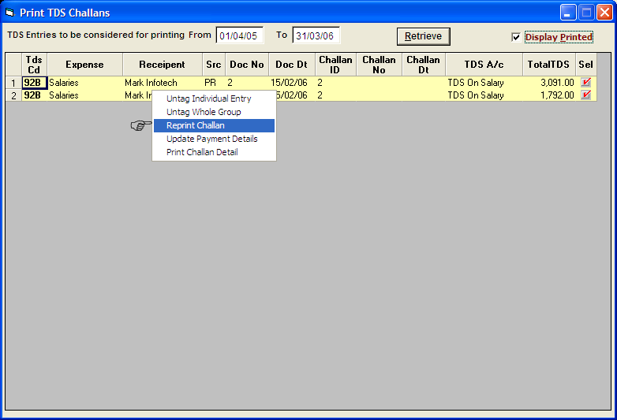

If for any reason you want to exclude one or more entries out of already printed challan, you can select the “Untag Individual Entry” option

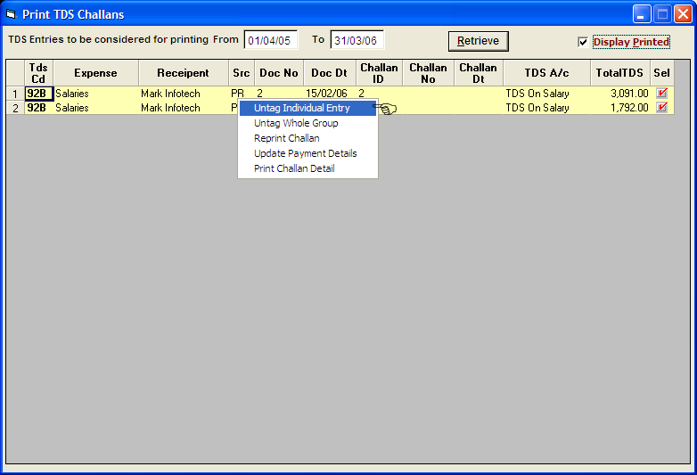

to exclude that entry from a particular challan, similarly you can also select untag whole group as shown below

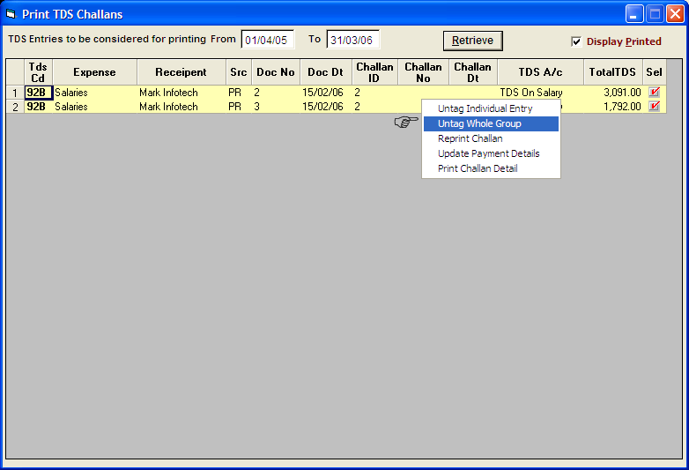

To cancel the entire challan and use the individual entries again to generate altogether new challan.

   

Step 9: Updation of Challan details

Once having printed the challan and paid the TDS amount in the bank you will receive a stamped copy of the same mentioning the BSR code and the entry no. which you need to update.

Check the “Display Printed” Select any one entry out of the whole challan, right click on it and select “Update Payment Details” option.

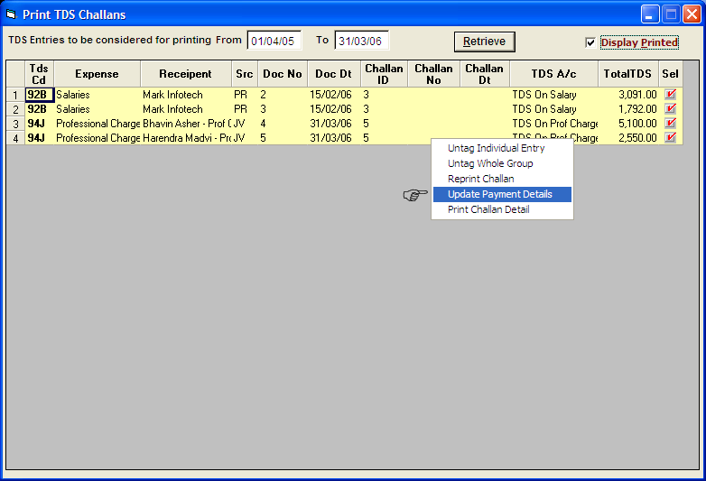

Wherein you need to enter the relevant details as shown below and click on proceed

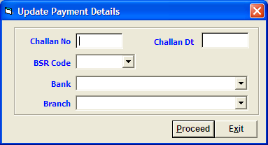

To replace the details so entered for all the entries of that challan as shown below.
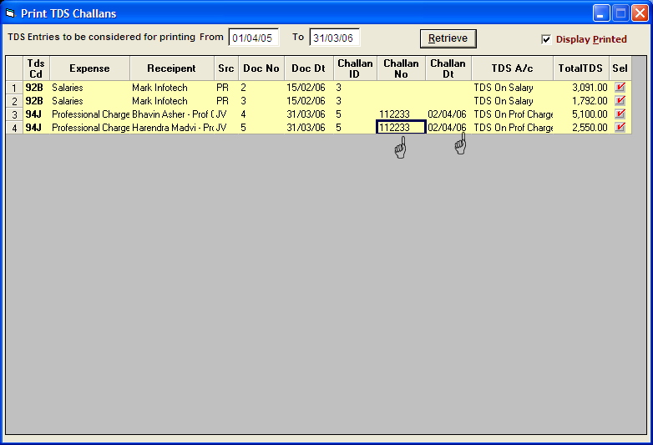

   

Step 9a : Updation of Quarterly TDS Return Acknowledgement number

Once the quarterly return is filed , you can update the acknowledgement number for the quarter

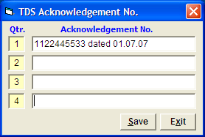

Step 10: TDS Certificate printing.

Once you have updated the challan details, you are in position to print the TDS Certificate from the interface as shown below. Select the entries you want to include in the certificate.

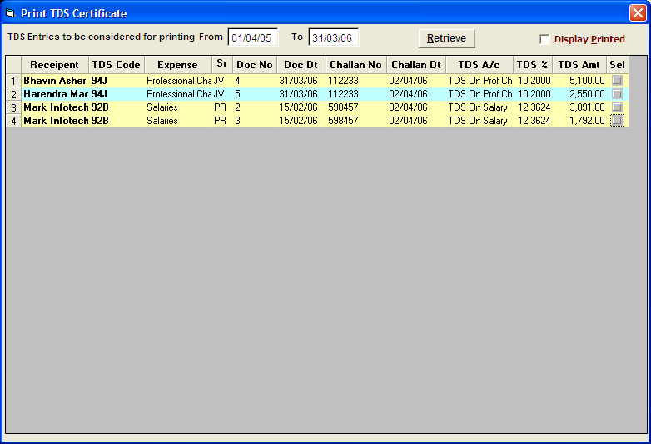

Right click on any one of the entries and select “Print Certificates”

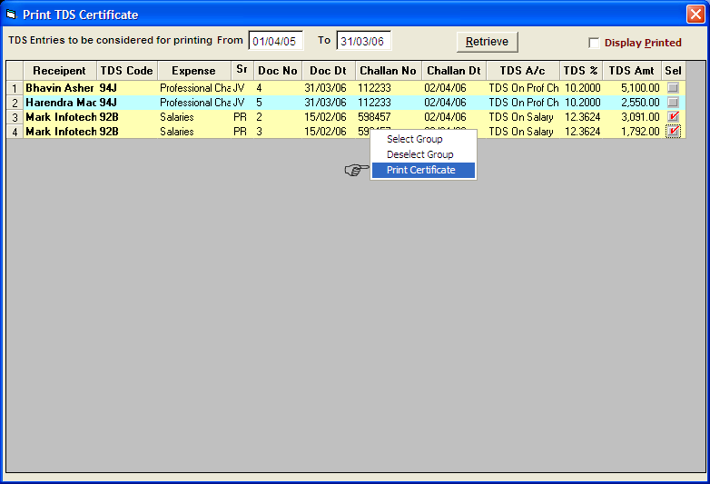

Enter the full name of the person signing the certificates and designation of the person signing the certificate as shown below
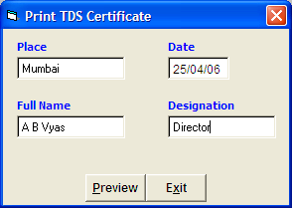 and click on button to print the certificate.

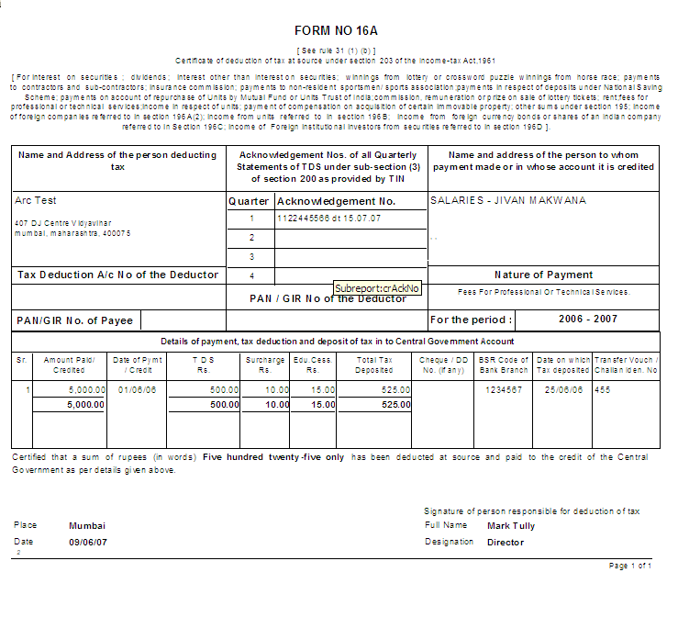

Reprinting TDS Certificate.

You can also re-print a certificate already printed by selecting check box as shown below to display all the printed TDS certificates.

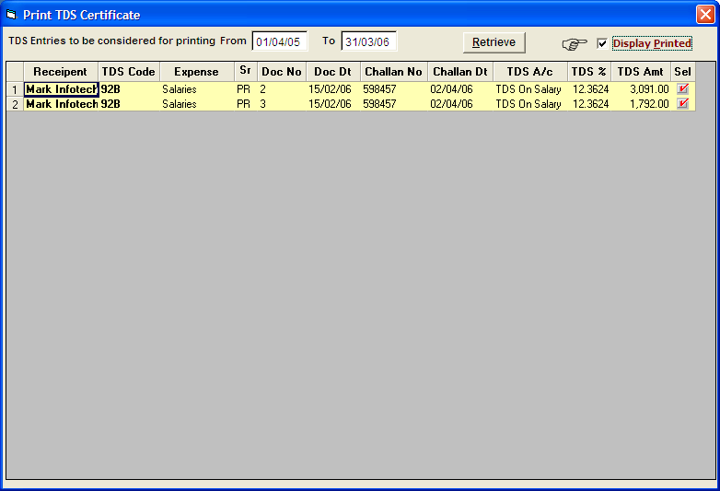

This facility will be useful in case if you need to re print TDS certificate.

  

Step 11: Quarterly TDS report.

You can also generate the quarterly TDS report which is required to be entered to create the e-TDS file for the purpose of electronic filing. Select the option “Utilities ->TDS option -> TDS Report” from menu and select the appropriate quarter and click on button.

On clicking on the generate report button all the relevant data will be displayed which you can print in the form of a report by right clicking on any one of the two tables and selecting “Print Preview”

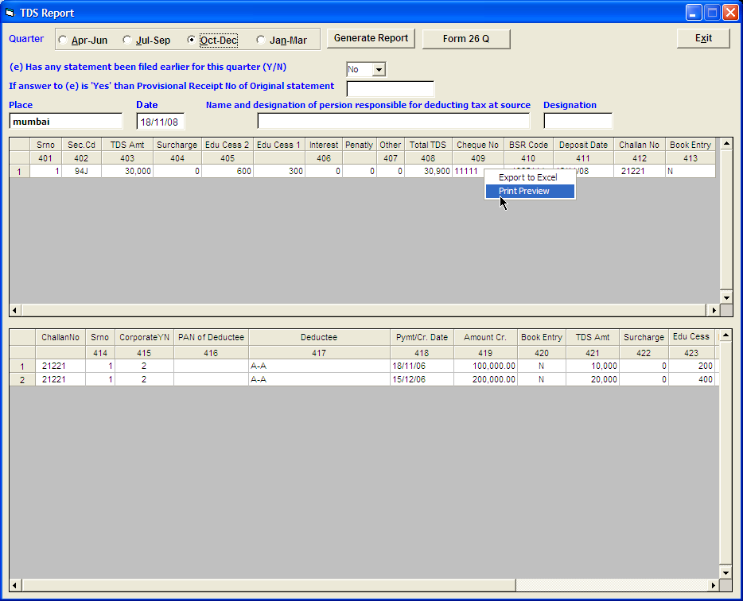

or “Export to Excel”, if required

Alternatively to generate Form 26Q , click on the button provided besides ‘Generate Report’

  

