SQL Server 2000 Desktop Installation

Double Click on the AUTORUN.EXE from the SQL Desktop Installation folder and follow the screen shots as shown below.
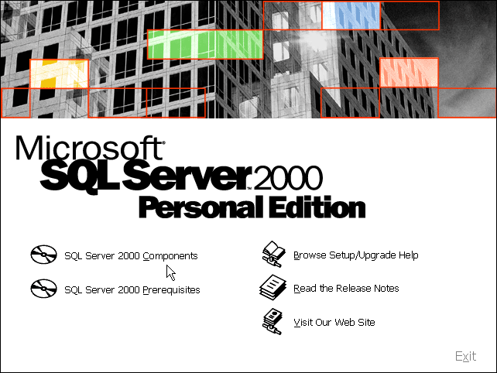
Click on SQL Server 2000 components

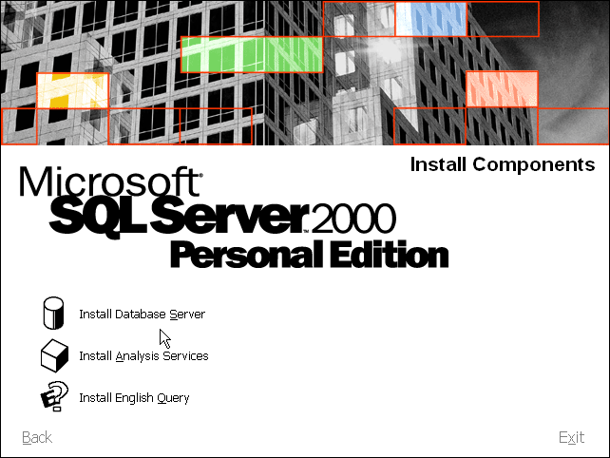
Click on “Install Database Server”

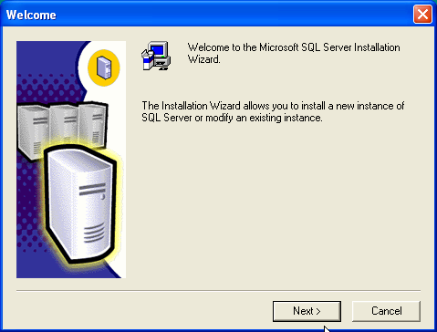
Click on

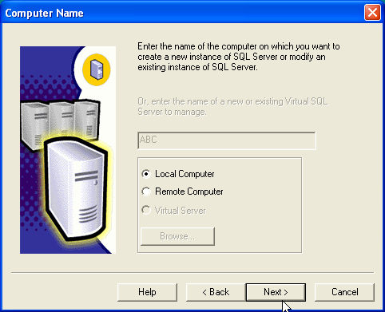
Should be selected, click on

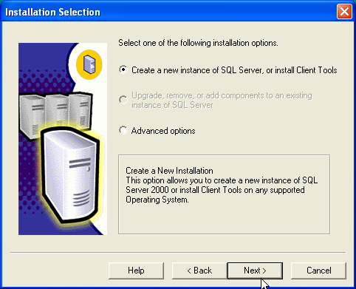
Should be selected, click on
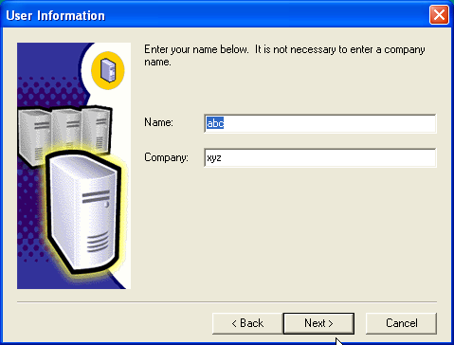
The user and company names are not important leave them as they are, click

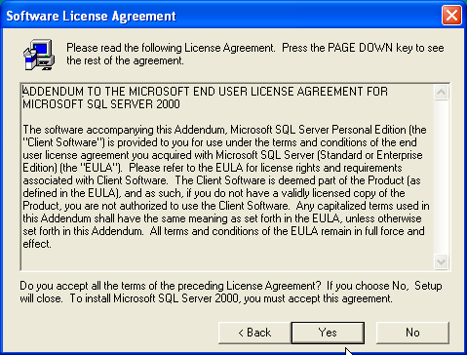
Click on
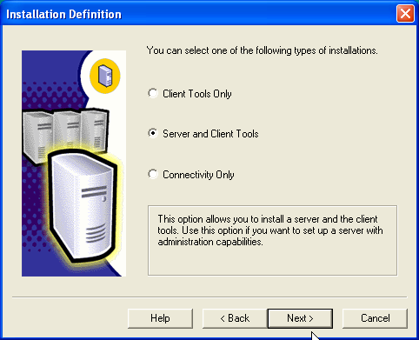
Ensure that is selected.

Uncheck the default option and enter the instance name as shown below
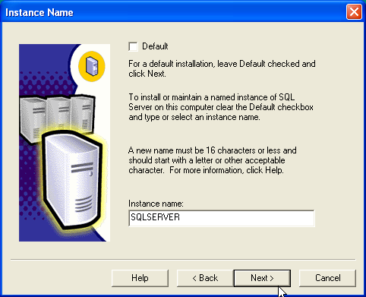
Click on

Select installation
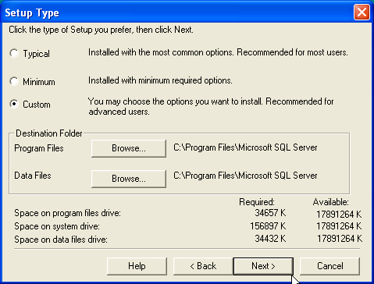
Click

For every component on the left hand side check all the sub components on right hand side.
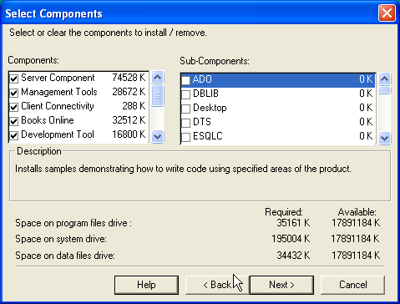
Click

Be sure to select the options shown below.
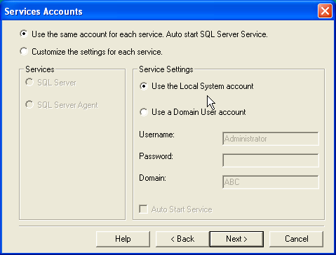
Click
Select the Mixed Mode Authentication and check blank password.
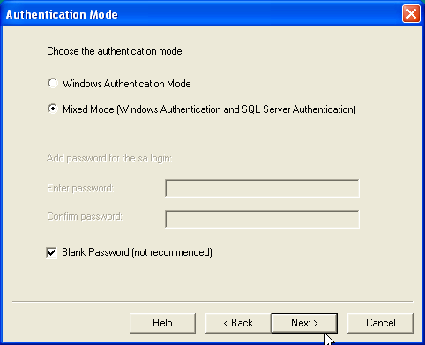
Click

No need to change anything here.
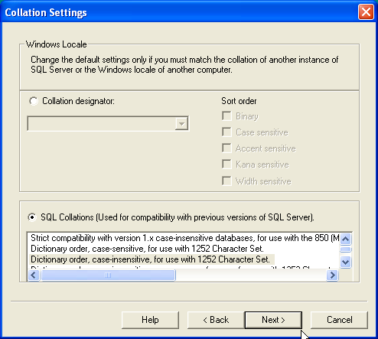
Click

Ensure that both the options are checked i.e. and. Also ensure that port number is entered as 1433.
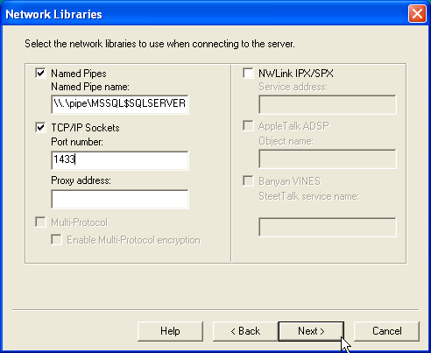
Click

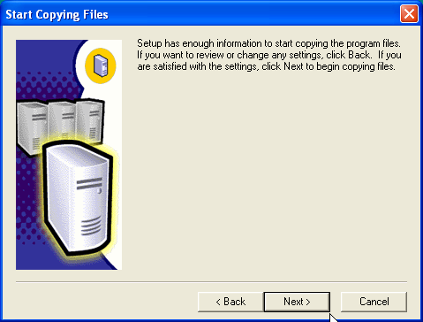
Click

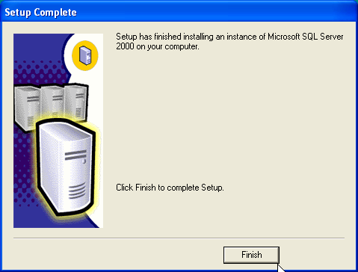
Click . You are done with installation of SQL 2000 Server desktop edition.
To start the SQL Services follow the next sequence of steps.

Click on Start ◻ Program ◻ MS SQL Server ◻ Server Manager. This will bring up the SQL Server Service Manager Window.

Click on button as well as check the option
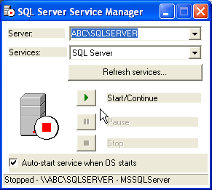

Click on the downward pointing arrow on services and select SQL Server Agent option. After selecting this again click and check the option. In both the above cases the Red square icon should turn to green arrow indicating that the service has started.
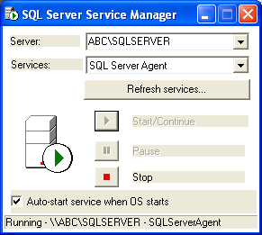

SQL Server Registration

To access the SQL server from Enterprise Manager, it should be first registered with the enterprise manager.

Click on Start -> Microsoft SQL Server -> Enterprise Manager

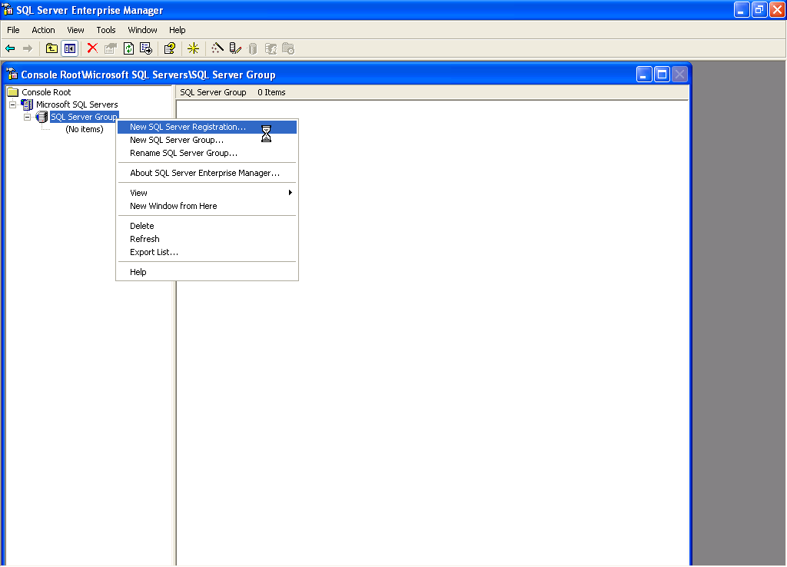

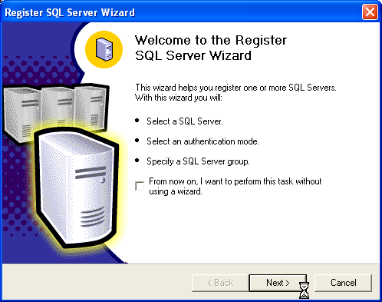

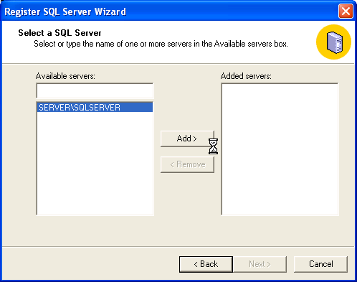

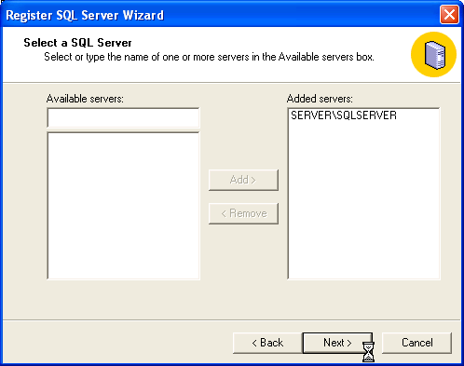

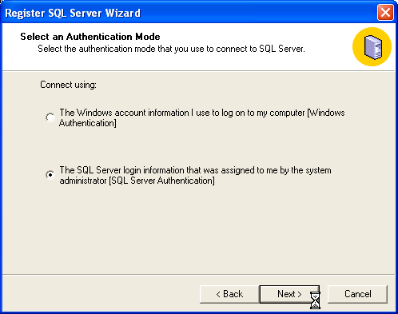

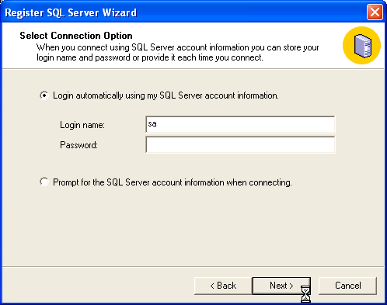

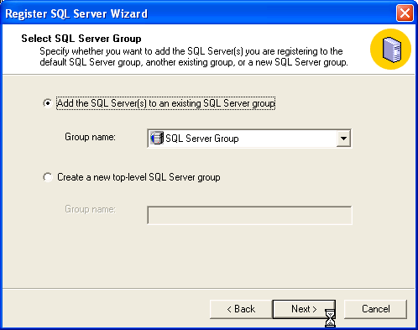

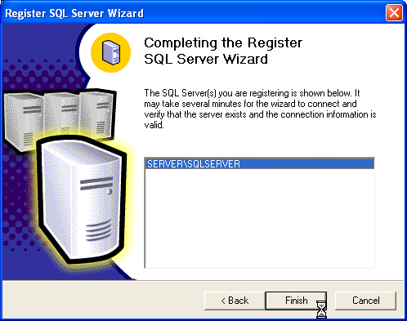

Once the SQL Server Service Manager starts, you need to ensure that the Enterprise Manager is able to connect to the SQL Server and attach your database to the SQL Server. Click on Start ◻ Program ◻ MS SQL Server Enterprise Manager to open the Enterprise Manager Window.

Expand the “Console Root” on the left hand side by clicking on “+” sign for every item till you have an option “Databases”. Right click on this option click on “All Tasks” and click on “Attach Database”.
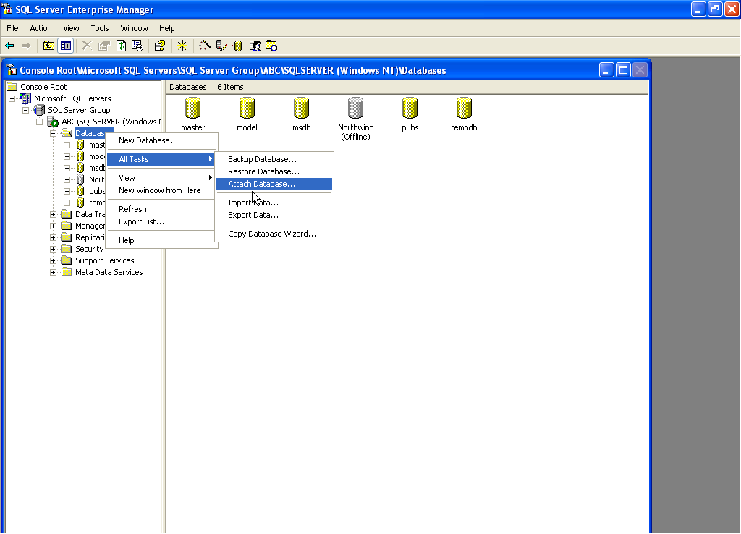

Select and click on the particular database file which you want to attach click on OK.
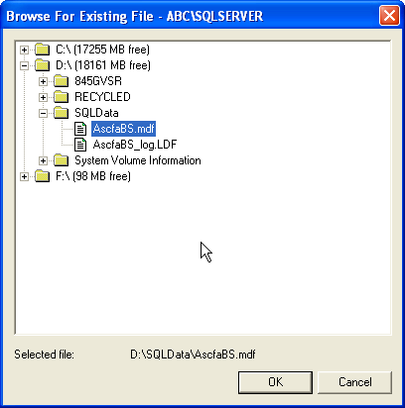

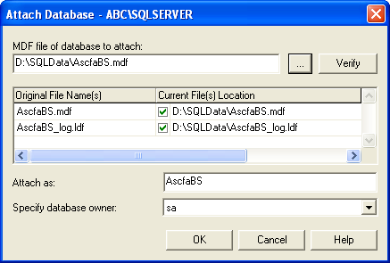

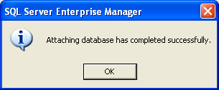

Having attached the database, you are now ready to run / install your application software.

For client systems (terminals) to access the SQL Server, you only need to install the SQL connectivity

SQL Server – Client Connectivity

On the work stations where from you need to connect to the SQL server to execute your applications, SQL Client Connectivity is to be established. To do this, execute the Setup.exe from the SQL Enterprise folder

Depending on your O/S you may get the following message.

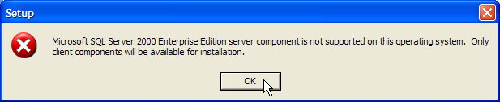

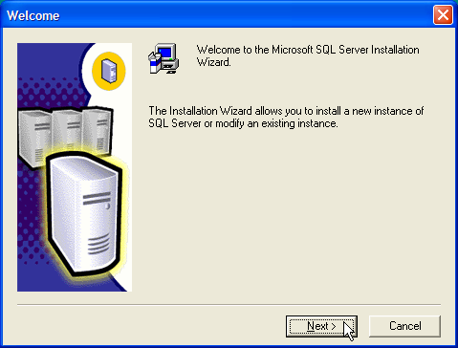

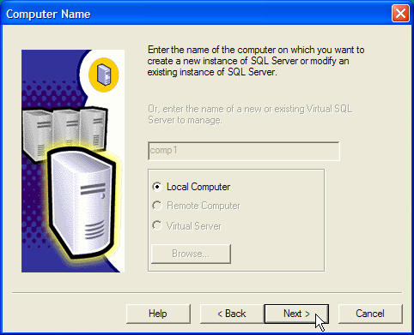

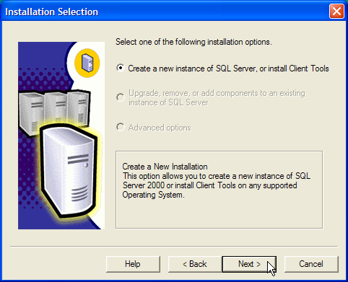

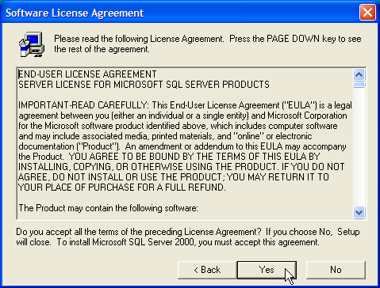

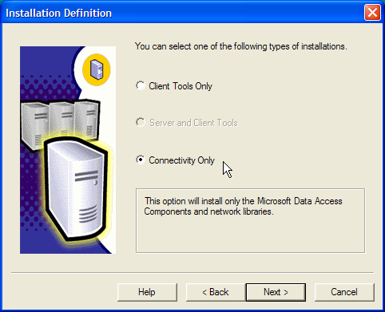

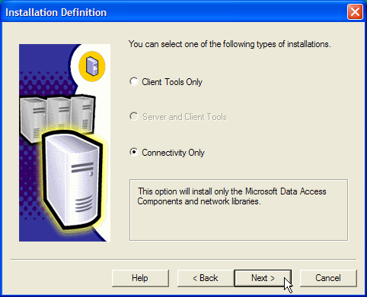

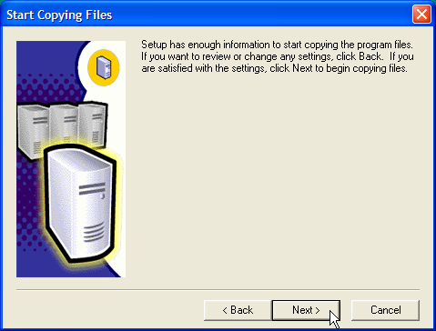

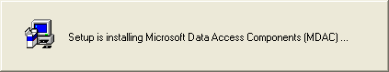

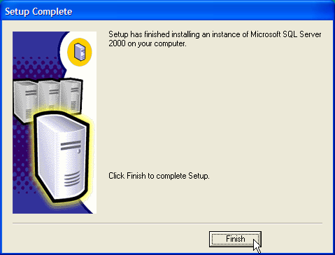

To check the connectivity now double click on the Microsoft Data Link file (eg ASCFAWin.UDL) in your application folder

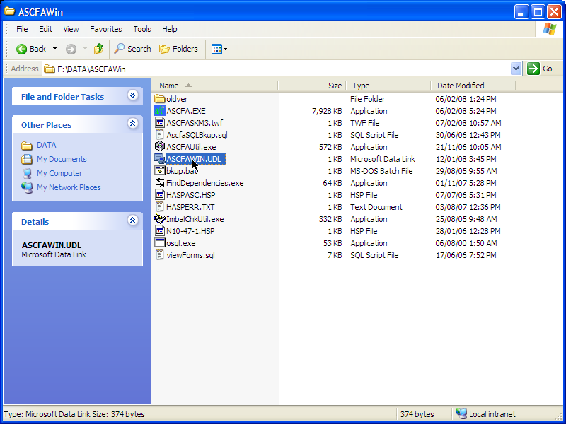

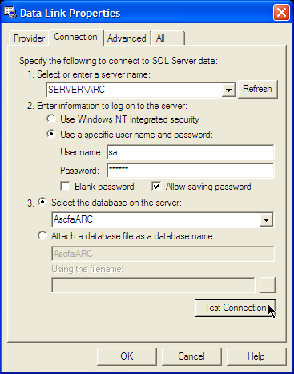

Click on the “Test Connection” button and you should get the following message.

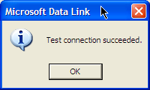

Now your terminal is connected to the SQL Server.

