Following Steps are required while during MSDE and Client Tools Installation

- MSDE Installation
- SQL Server Client Tools Installation
- Confirm SQL Server Instance Registration
- Attach Database

1. MSDE Installation

1.1 Open MSDE Folder and Check Setup.ini file settings
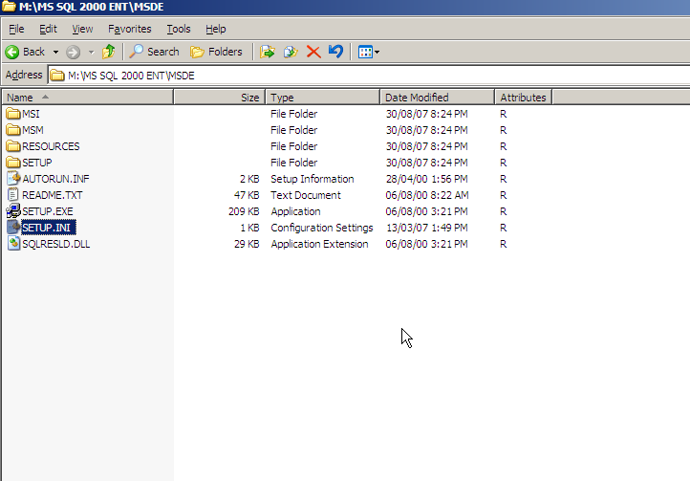

1.2 Ensure the file has the following text inside it, if not then enter the following and save the file

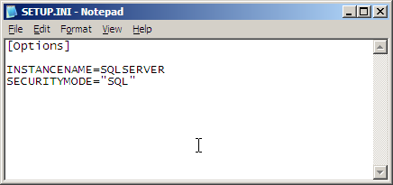

1.3 Double click on Setup.Exe to start the installation of MSDE

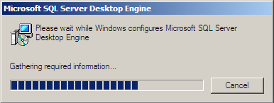
Installation will end without any completion notice. It would take around 3 – 5 minutes for installation, the computer may show no activity but the installation continues. Please be patient for couple of minutes for the installation to get through.

Once completed you may check the Control panel – Add / remove programs option, and find Microsoft SQL Server Desktop Engine (SQLSERVER) component there.

2. SQL Server Client Tools Installation

2.1 Double Click on Autorun.exe file in ENT / main SQL Server installation folder, Select SQL Server 2000 Components here

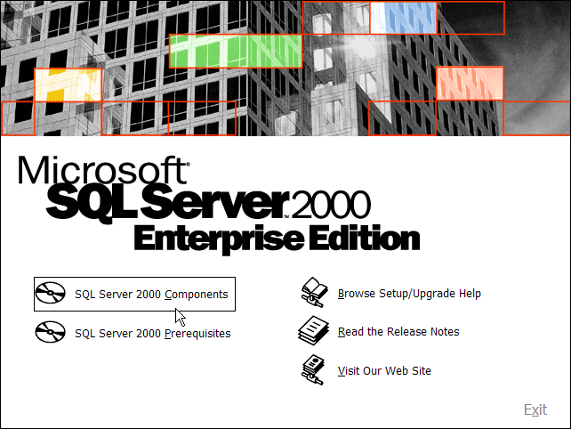

2.2 Select Install Database Server

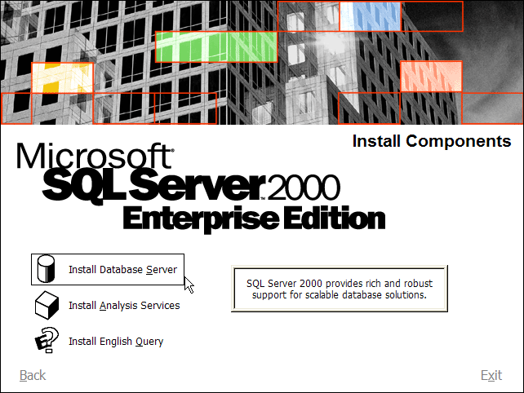

2.3 When following message appears, click OK to continue

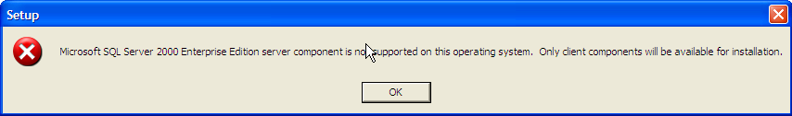

2.4 Click Next to continue
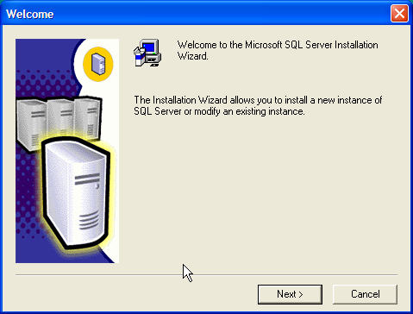
2.5 Click Next to continue
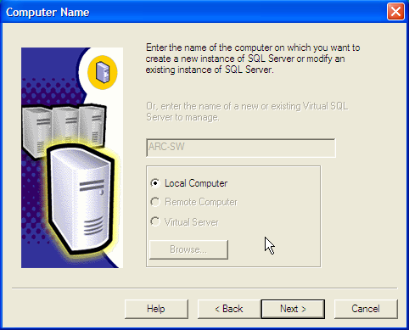
2.6 Click Next to continue
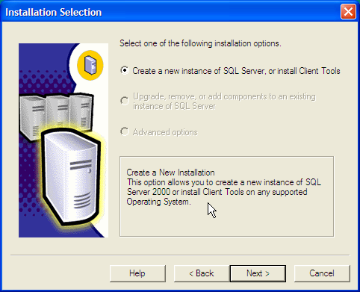
2.7 Set the name and company and then Click Next to continue
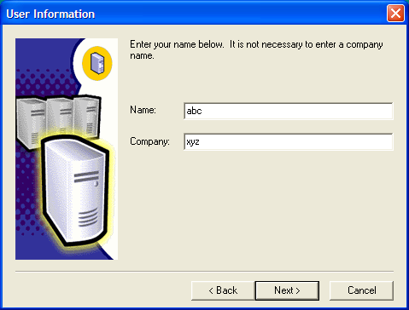

2.8 Click YES to continue
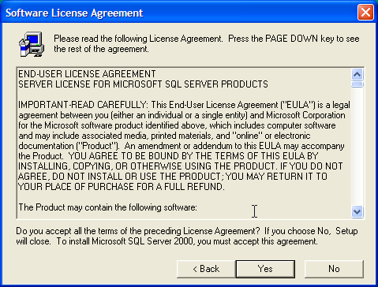

2.9 Select Client Tools only and Click Next to continue
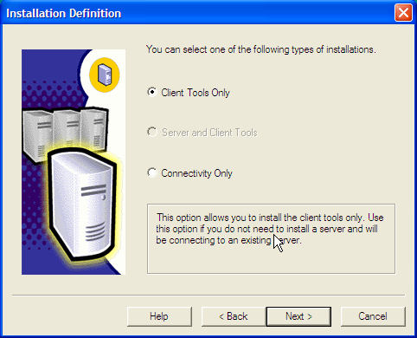

2.10 Ensure that all the options in both the windows are selected, Click Next to continue
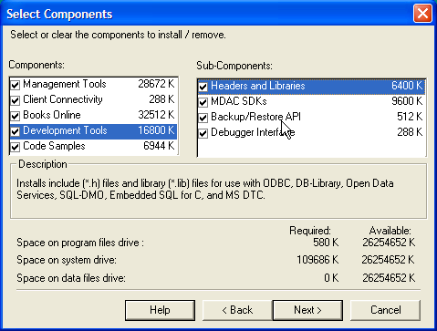

2.11 Click Next to continue
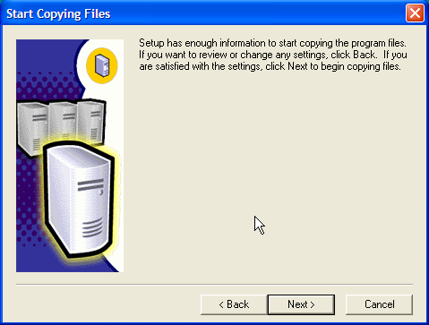

2.12 Following message appears, indicating progress of the installation

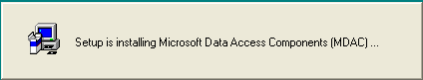

2.13 Following message appears, indicating progress of the installation
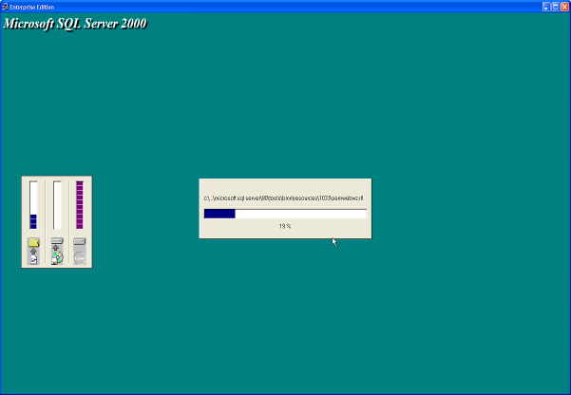

2.14 Installation of Client Tools ends, click finish to close

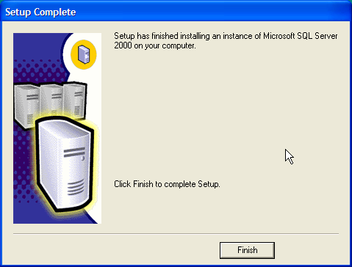

3. Confirm SQL SERVER Instance Registration

3.1 Click on Start – Program files - Microsoft SQL Server – Enterprise Manager

3.2 Click on Plus Sign besides Microsoft SQL Server, to expand the options

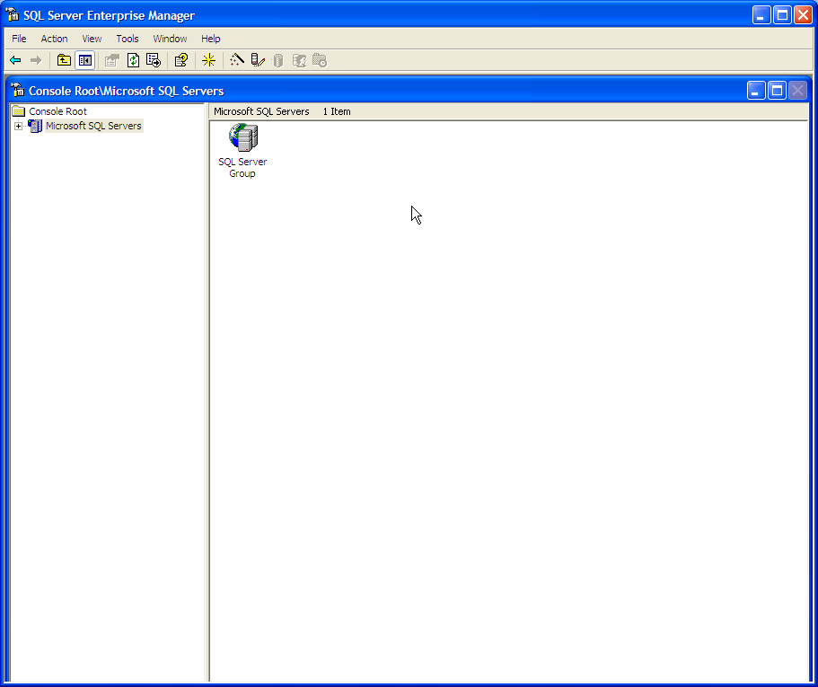

3.3 Click on Plus Sign besides SQL Server Group, to expand the options

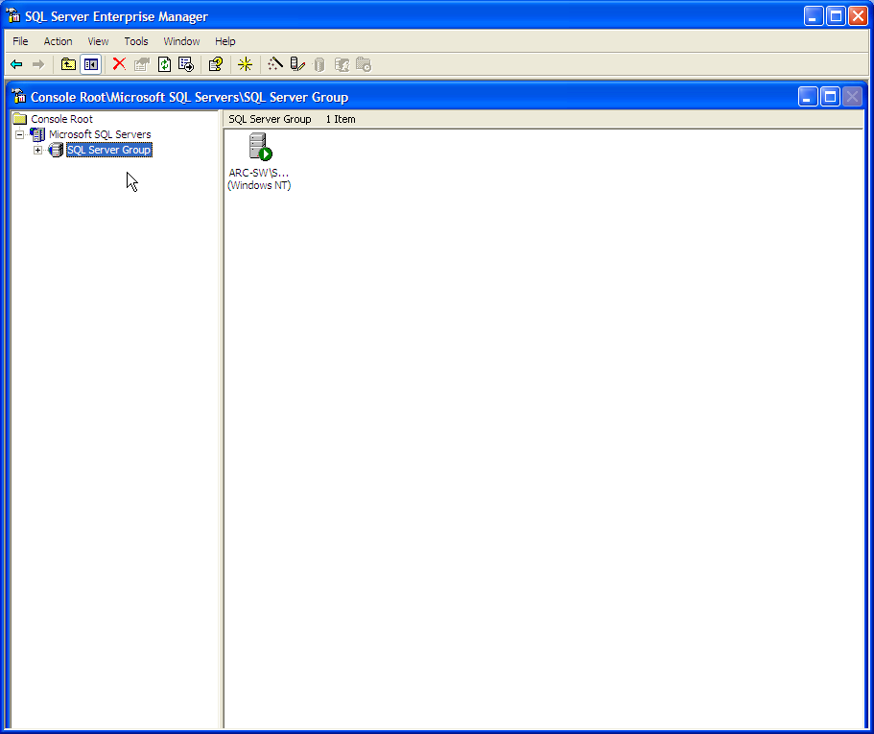

3.4 Click on Plus Sign besides SQL Instance Name (ARC-SW here, it may be different with you), to expand the options

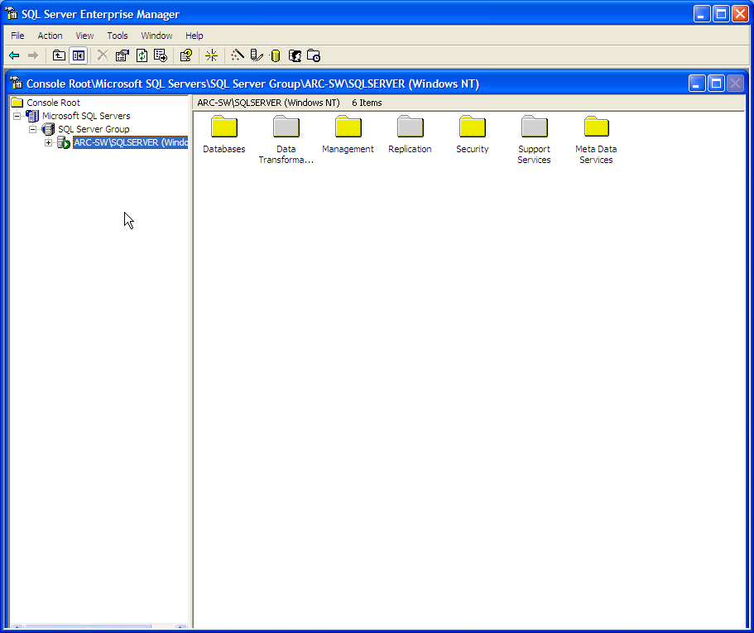

3.5 Lastly the options shown would appear as below. This indicates that you have installed the database properly.

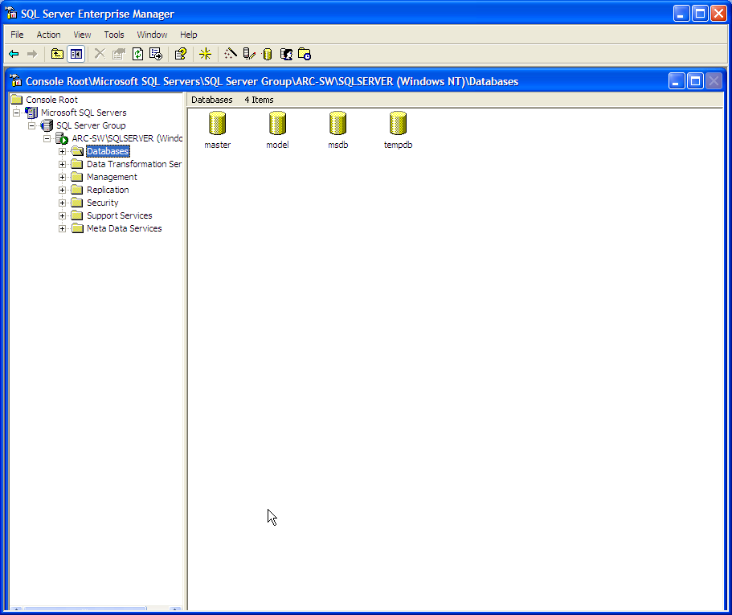

4. Attach Database

Application database should be attached for the application to access the data.

4.1 Click on Start – Program Files – Microsoft SQL Server – Enterprise Manager – Expand as shown below.

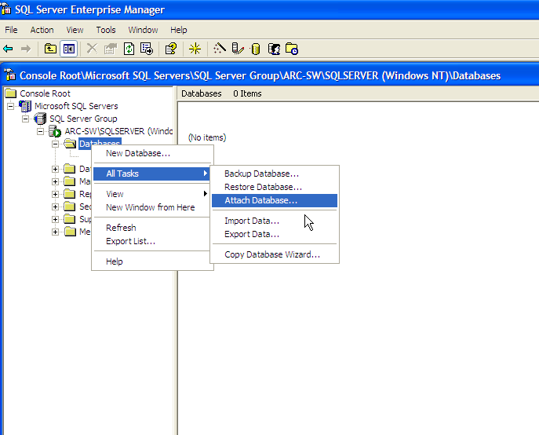

4.2 Attach database window, allows you to pickup the database and attach it. Click on the button shown below to specify the database path.

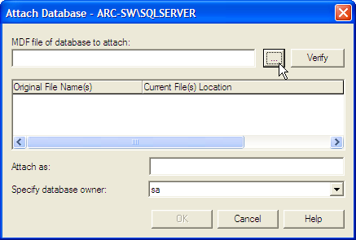

4.3 Select the database files (Only .MDF)
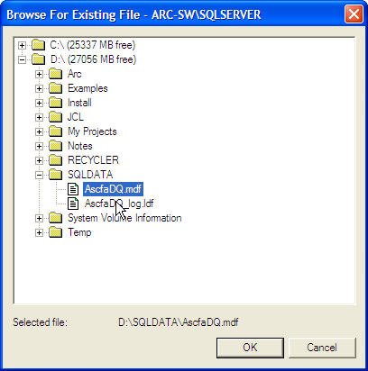

4.4 Ensure that the information is correct in the Current File(s) Location and Attach as text box. Then click on Ok

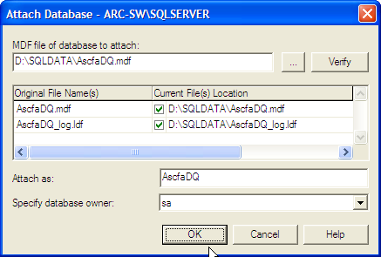

4.5 Database attached successfully message appears

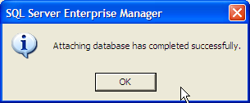

4.6 Confirm the database is attached properly.

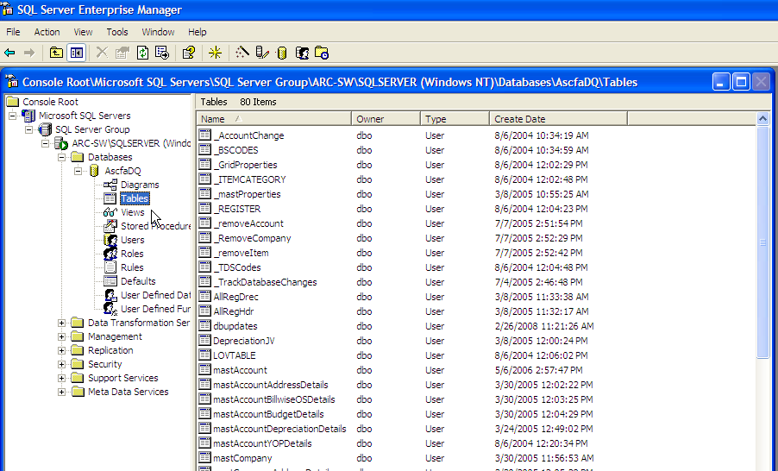

END OF INSTRUCTIONS

