BACKUP / RESTORE DATABASE

Your accounts database can be backed up and restored either using the utility provided within ASCFA itself or through the SQL Enterprise Manager

Backup Restore – from within ASCFA

A new menu option has been provided in the ASCFA package for the users to backup and restore the database if required.

Before using the backup option, kindly update the backup folder / path in the group setup.

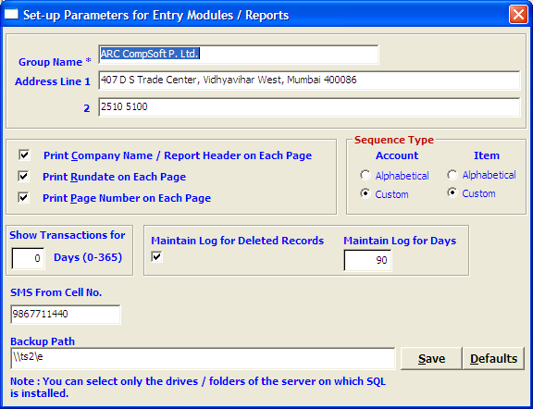

Once the backup folder details are updated, you can use the Backup database option.

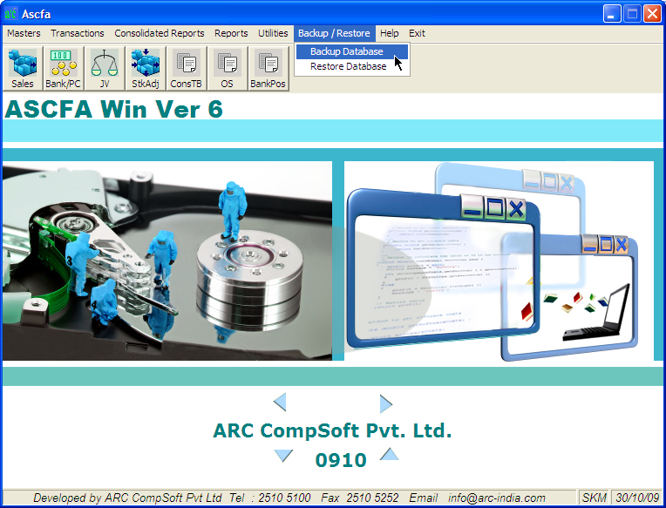

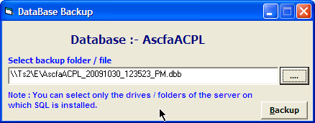

- As such you can backup the database even when users are logged in, how ever it is always prudent to backup the database when other users are not logged in.
- This utility is accessible by users who are equivalent to ‘Supervisor’ only
- If you are using a ‘Viewer’ version then the Backup option is not available

Restore database

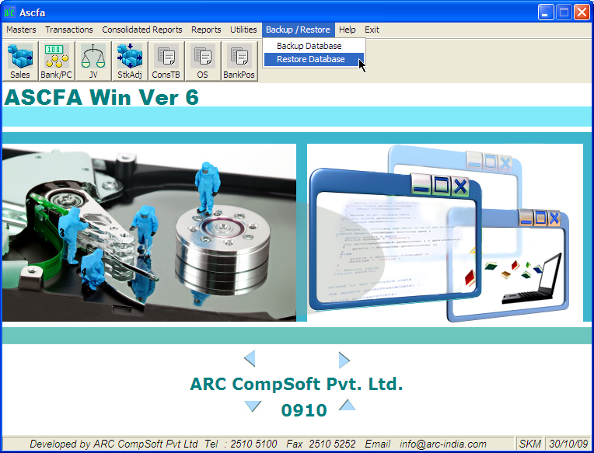

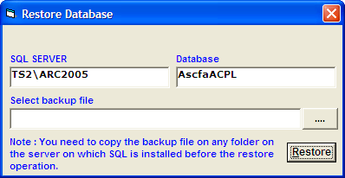

- For restoring the database you have to copy the backup file to the same system on which the SQL server is installed.
- The SQL server name and the database name are displayed for information purpose only and cannot be changed
- If any other users are logged in, the restore button will be disabled.

Back Restore data – FROM SQL

Unlike a DOS based application where in your data is stored in number of individual files, with Windows + RDBMS application your entire set of data is stored in one single database file.

This makes it easier for you to back up your data as and when required. Another advantage is that you can take the back up even when the users are working on the package.

With SQL Server you have an option of taking the back ups manually as and when required or automating this process so the backups are taken at pre-determine time intervals.

For either of these modes, it is necessary that MS SQL Enterprise manager should have been loaded on the system.

Manual Backup
Automatic Backup
Restore

Manual Back up:

Click on start  Programs  Microsoft SQL Server  Enterprise Manager.
Expand Console Root by clicking on the “+” sign in the left pane.

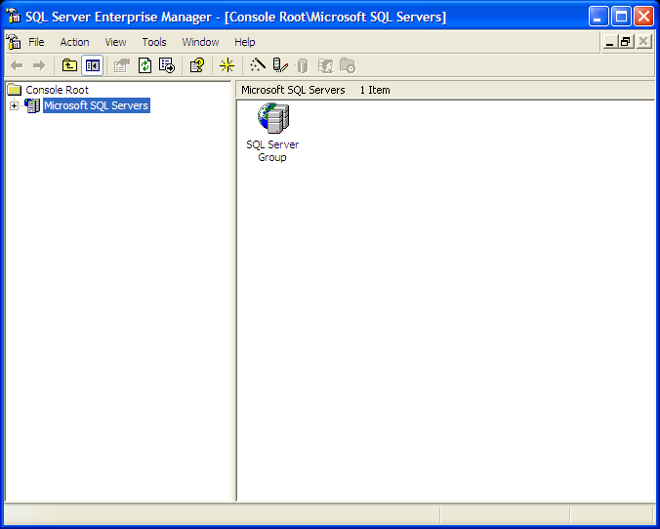

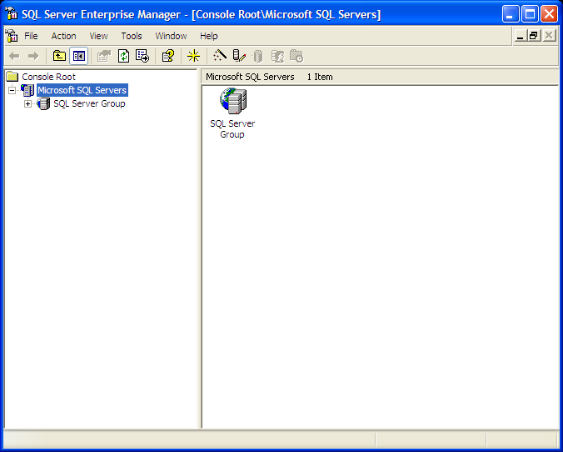

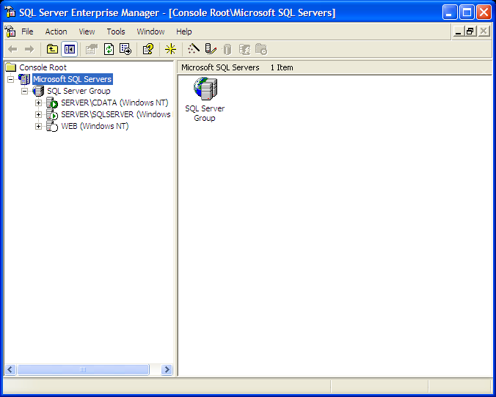

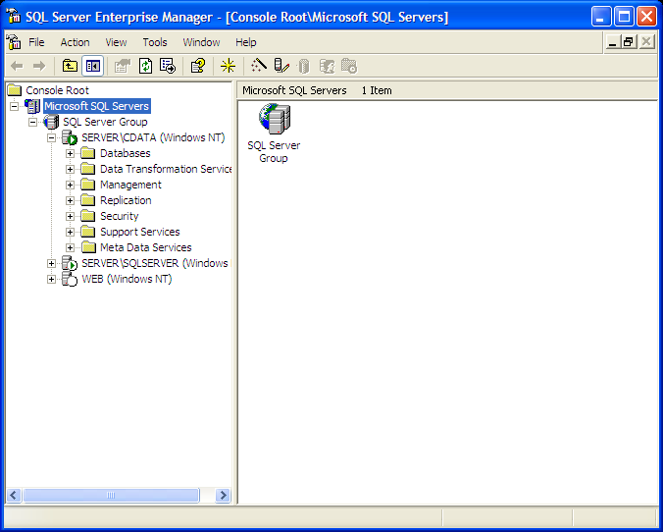

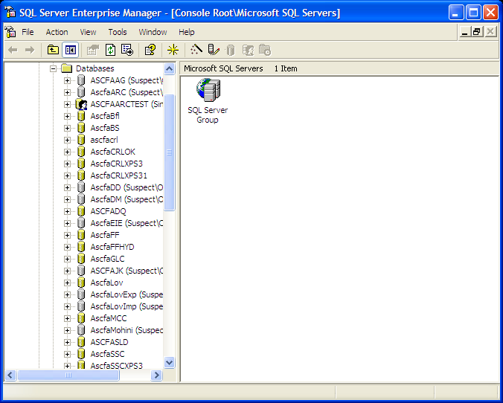

Till you are able to see your database. The database name starts with “ASCFA” and is suffixed with the company name. For example the database name for ARC would be “ASCFAARC” and for Terminal Technologies would be “ASCFATT”.

Right click on the database name,

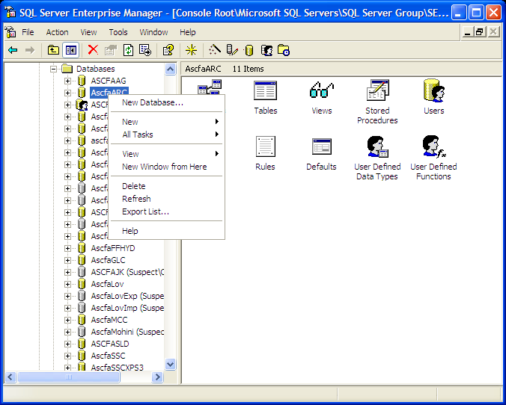

Click on “All tasks”,

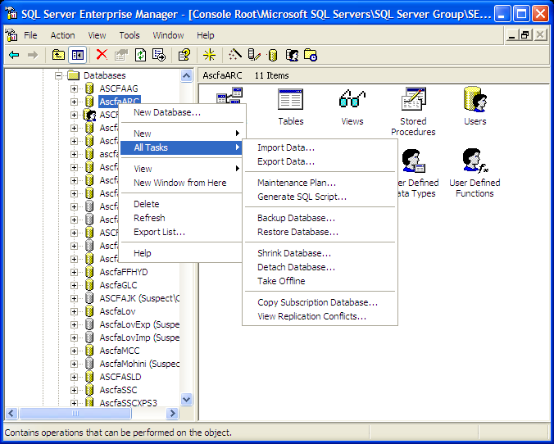

Click on “Backup database…”

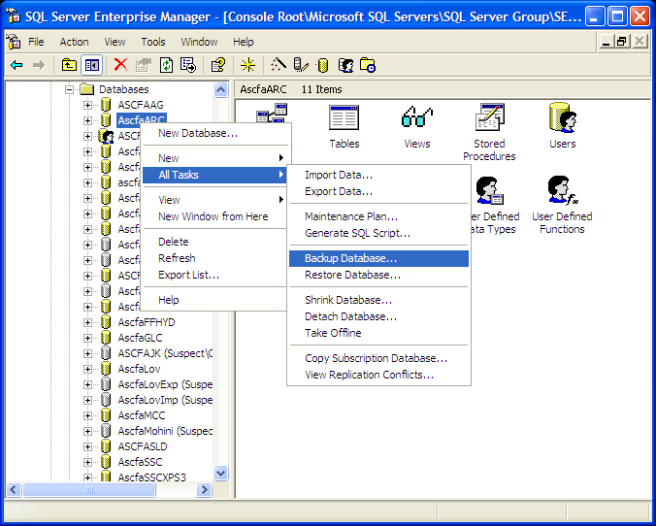

The following SQL Server back up window will open up

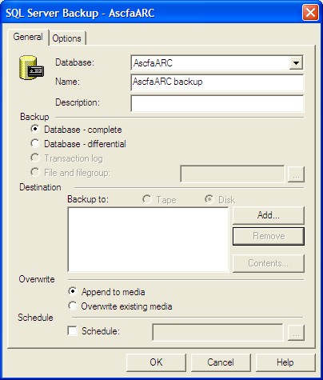

Click on button and the Select Back up Destination window opens up. Enter the back up file name with the full folder name with an extension .dbb as shown below

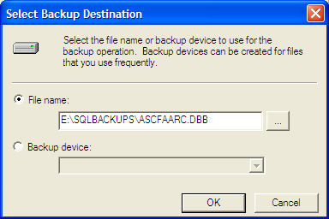

And click on OK. Click on OK again in the SQL Server Back up window

And you would see the progress of the back up as shown below

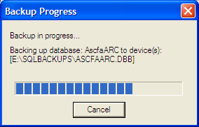

Once the Back up is done you will see the confirmation to that affect.

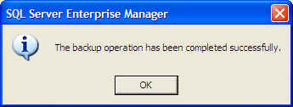

The file with an extension .dbb will be created in the folder you have specified. Be sure to copy this file on to another computer or another media for additional safety.
Automatic Back up:

You can define a scheduled back up to be executed at pre-determined time interval.

Click on Start  Programs  Microsoft SQL Server  Enterprise Manager.
Expand console Root by clicking on the “+” sign in the left pane.)

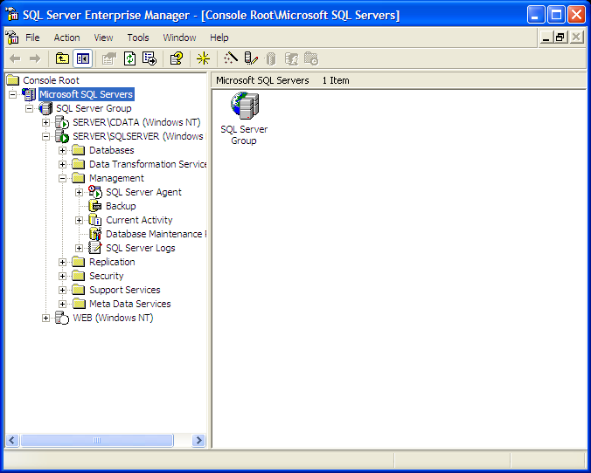

Right click on Database Maintenance Plan

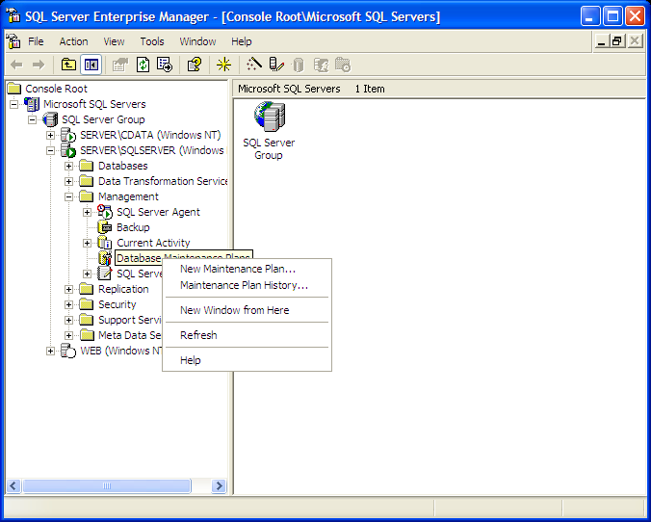
Select New Maintenance Plan

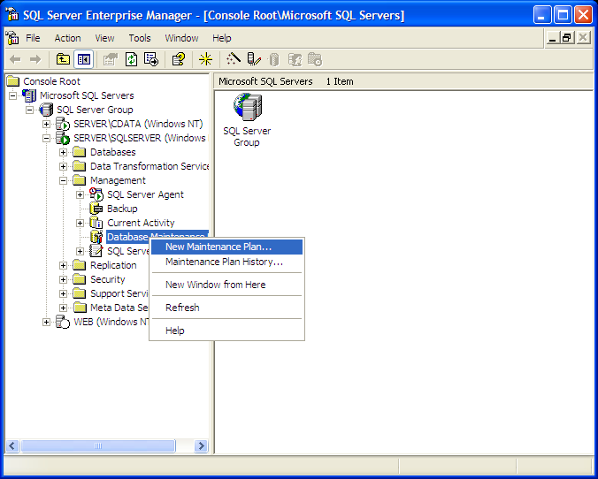

Click on

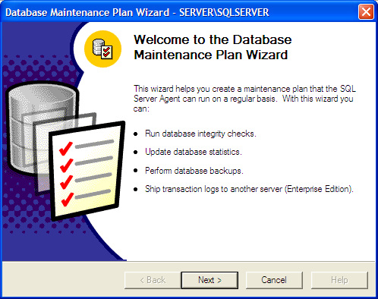

Check your database out of the list shown, click on

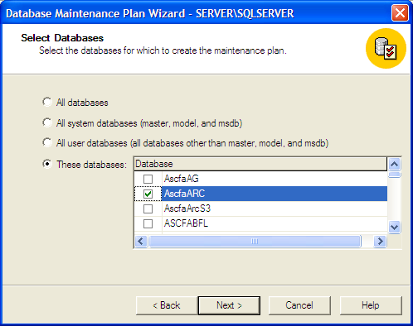

Click on

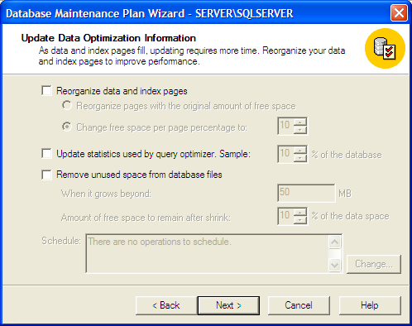

Click on

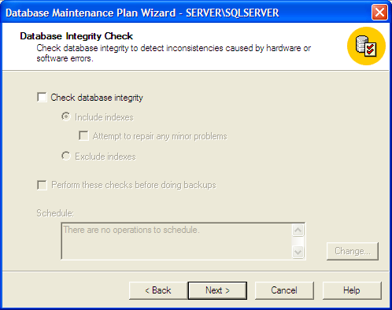

Ensure that backup the database is checked and verify integrity is also checked and the Disk option is selected as shown below

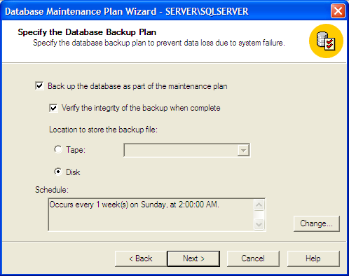

Click on Change, select daily ad select the time and click on OK

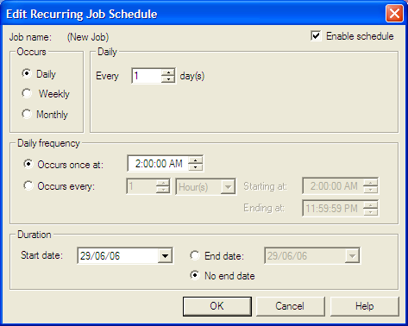

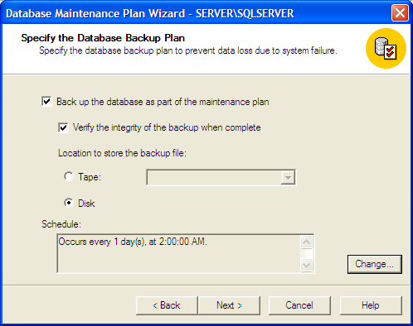

Click on

Select Use this Directory and Enter the Directory name where you want to place the back up. Change the back up file extension to dbb and click on next

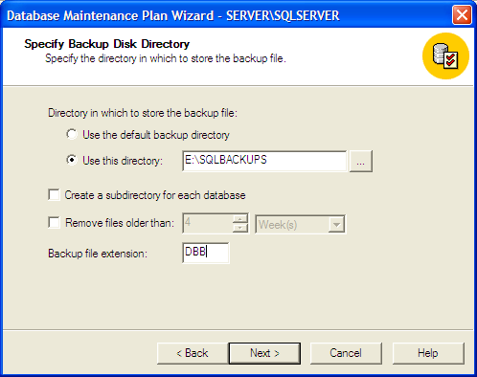

Click on

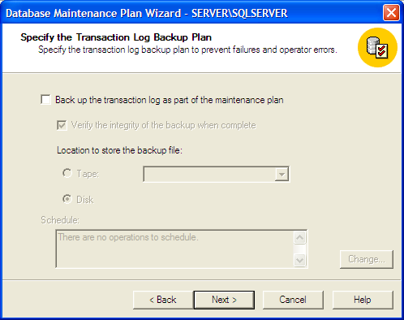

Click on

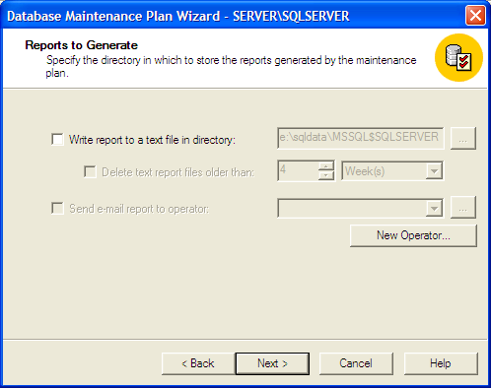

Click on

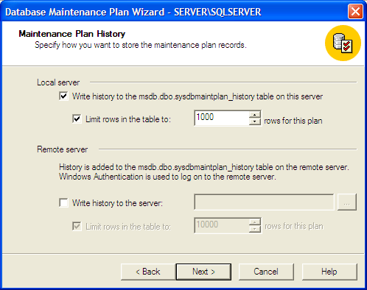

You can change the plan name to some understandable description and click

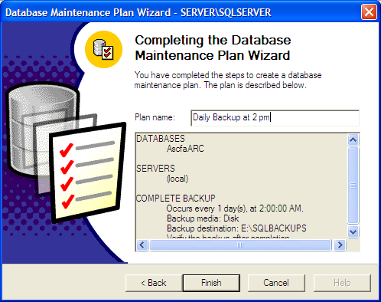

Once you have executed this properly your data base back up plan should appear on the right hand pane of the Enterprise Manager as shown below

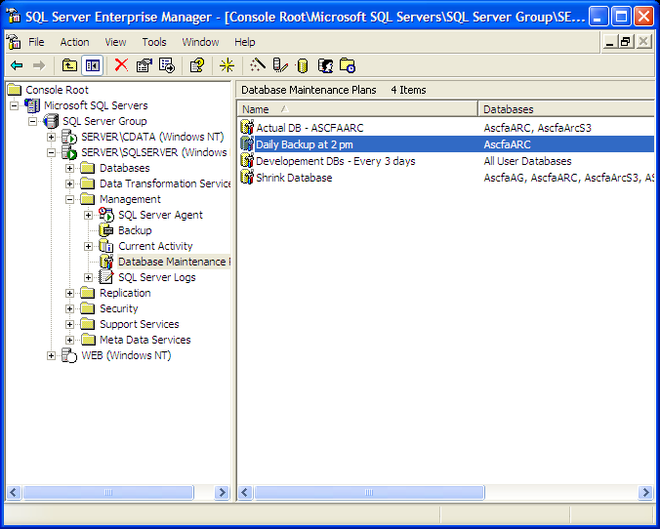

In case of automated backup maintenance plan created as shown above , the file name will be suffixed with the date & time and with extension .dbb

E.g., in the above case the backup file on 26.06.06 will have the name ASCFAARC_db_200606261400.dbb as it is being taken at 2 PM.

Restore Database

Restoration of data is pretty simple.

Click on start  Programs  Microsoft SQL Server  Enterprise Manager.
Expand Console Root by clicking on the “+” sign in the left pane , till your database is visible.

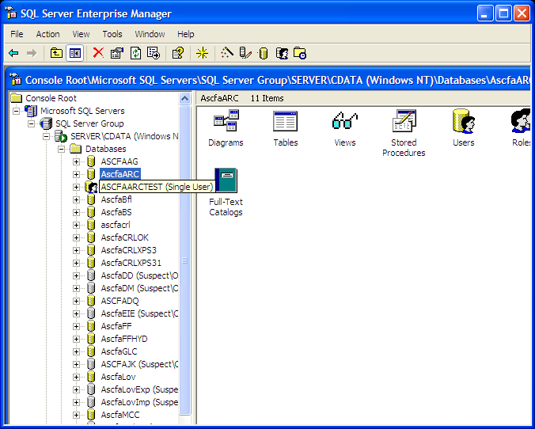

Right click on the database name

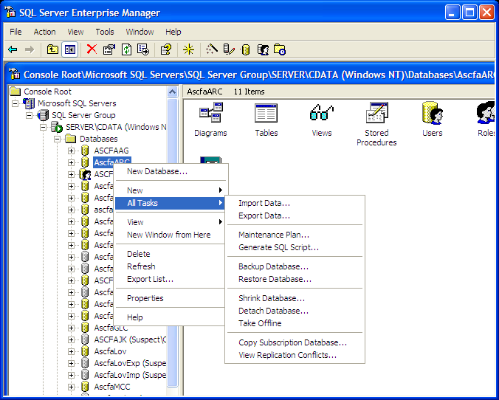
Click on Restore Database….

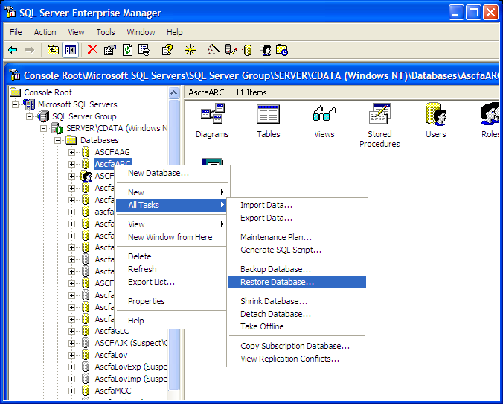

The restore database window opens as under

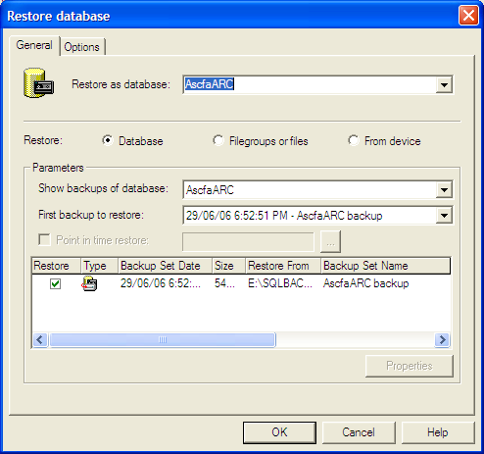

Displaying the backup sessions that have been taken earlier. Select the last backup session and click OK

The restore process starts and progress as under

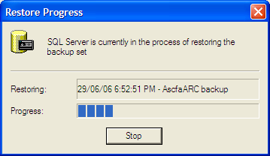

Once restore is complete, you get a confirmation as under



